CIVIL LAW PAPER I · ISLAMABAD HIGH COURT · CIVIL JUDGE-CUM-MAGISTRATE EXAMINATION 2026
Topic 2 · Questions and Model Answers
CPC 1908 (Part II) — judgment, special suits, interim relief, execution, appeals, review and revision — ten examination questions answered in full
Drawn from KP High Court 2026, Sindh High Court 2022, Lahore High Court 2017–2023 and LHC ASJ 2020 papers, and Punjab University CPC papers

Prepared for: Ihtisham Ul Haq (Roll No. 999)
Paper: Civil Law-I — Monday, 26 October 2026, 2:00 PM to 5:00 PM
Companion volume: Topic 2 — Knowledge Base (read the relevant chapter before each answer)
Format: At a glance · The answer map · Decoding the question · The model answer · Why this answer scores

Contents
How to use these model answers 3
Answer 1 · Ingredients for the grant of a temporary injunction (SHC 2022) 4
Answer 2 · Write the order of temporary injunction — public servant and official residence (LHC 2017) 8
Answer 3 · Scope of review, revision, appeal and second appeal (LHC 2023) 12
Answer 4 · Review (s. 114) and amendment of judgments (s. 152) (KPHC 2026) 18
Answer 5 · Interpleader suits — how and where instituted, and their rules (KPHC 2026) 22
Answer 6 · Summary suits — leave to defend and denial of consideration (LHC 2023) 26
Answer 7 · Guardian ad litem; deciding minority; decree against an unrepresented minor (LHC 2023) 30
Answer 8 · Auction-purchaser's possession obstructed — is the r. 97 inquiry warranted? (LHC ASJ 2020) 34
Answer 9 · Procedure for executing a money decree; the competent court (PU LLB 2008) 38
Answer 10 · Suit against Government without notice — s. 80 and Order XXVII (PU LLB 2007) 42
zzTOCENDzz

How to use these model answers

The ten questions
No. | Question (short title) | Source | Type
1 | Ingredients for the grant of a temporary injunction; cases where injunction cannot be granted | SHC 2022, Q. 1 and Q. 4 | Theory
2 | Write the order of temporary injunction — public servant and official residence | LHC 2017, Civil Law-II, Q. 2 | Practical (order)
3 | Scope of review, revision, appeal and second appeal, with differences | LHC 2023, Civil Law-II, Q. 9 | Theory
4 | Review (s. 114) vs amendment of judgments (s. 152) | KP High Court 2026, Q. 4 | Theory
5 | Interpleader suit — how and where instituted; its rules | KP High Court 2026, Q. 1 · LHC 2017 short note | Theory
6 | Summary suits — leave to defend; denial of consideration; onus | LHC 2023, Civil Law-II, Q. 8 | Theory + problem
7 | Guardian ad litem; deciding minority; decree against an unrepresented minor | LHC 2023, Civil Law-II, Q. 7 | Theory
8 | Auction-purchaser's possession obstructed — is the r. 97 inquiry warranted? | LHC ASJ 2020, Civil Law-II, Q. 1 | Problem
9 | Procedure for executing a money decree; competent court | Punjab University LLB (CPC) 2008, Q. 7 | Theory
10 | Can a suit be filed against Government without notice? Details | Punjab University LLB (CPC) 2007, Q. 4 | Theory (Pakistani law)

The five parts of every answer
- At a glance — the source, the marks and the exact question.
- The answer map — a one-page picture; each box is one numbered heading of the answer. Draw a rough version in the exam before writing.
- Decoding the question — what the examiner wants.
- The model answer — headings, bare-Act quotations, one case per point, an illustration and a conclusion.
- Why this answer scores — the techniques to copy.
EXAM TIP · Pakistani law wins marks in this topic
Five Topic 2 answers turn on rules that differ from Indian textbooks: no abatement (O. XXII), s. 80 notice not a bar, no separate suit after execution claims (O. XXI rr. 62, 103), deposit before objection (O. XXI r. 23-A), and time limits on injunctions (O. XXXIX rr. 2A, 2B, 4A). Quote them — they show the examiner you have read the law in force in Islamabad.

Answer 1 · Ingredients for the grant of a temporary injunction (SHC 2022)
AT A GLANCE · SINDH HIGH COURT 2022 · CIVIL LAW · Q. 1 (with Q. 4 short note) · 20 MARKS
Discuss the ingredients for the grant of a temporary injunction under Order XXXIX Rules 1 and 2 CPC. (Short note, Q. 4: "Cases in which injunction cannot be granted".)

The answer map
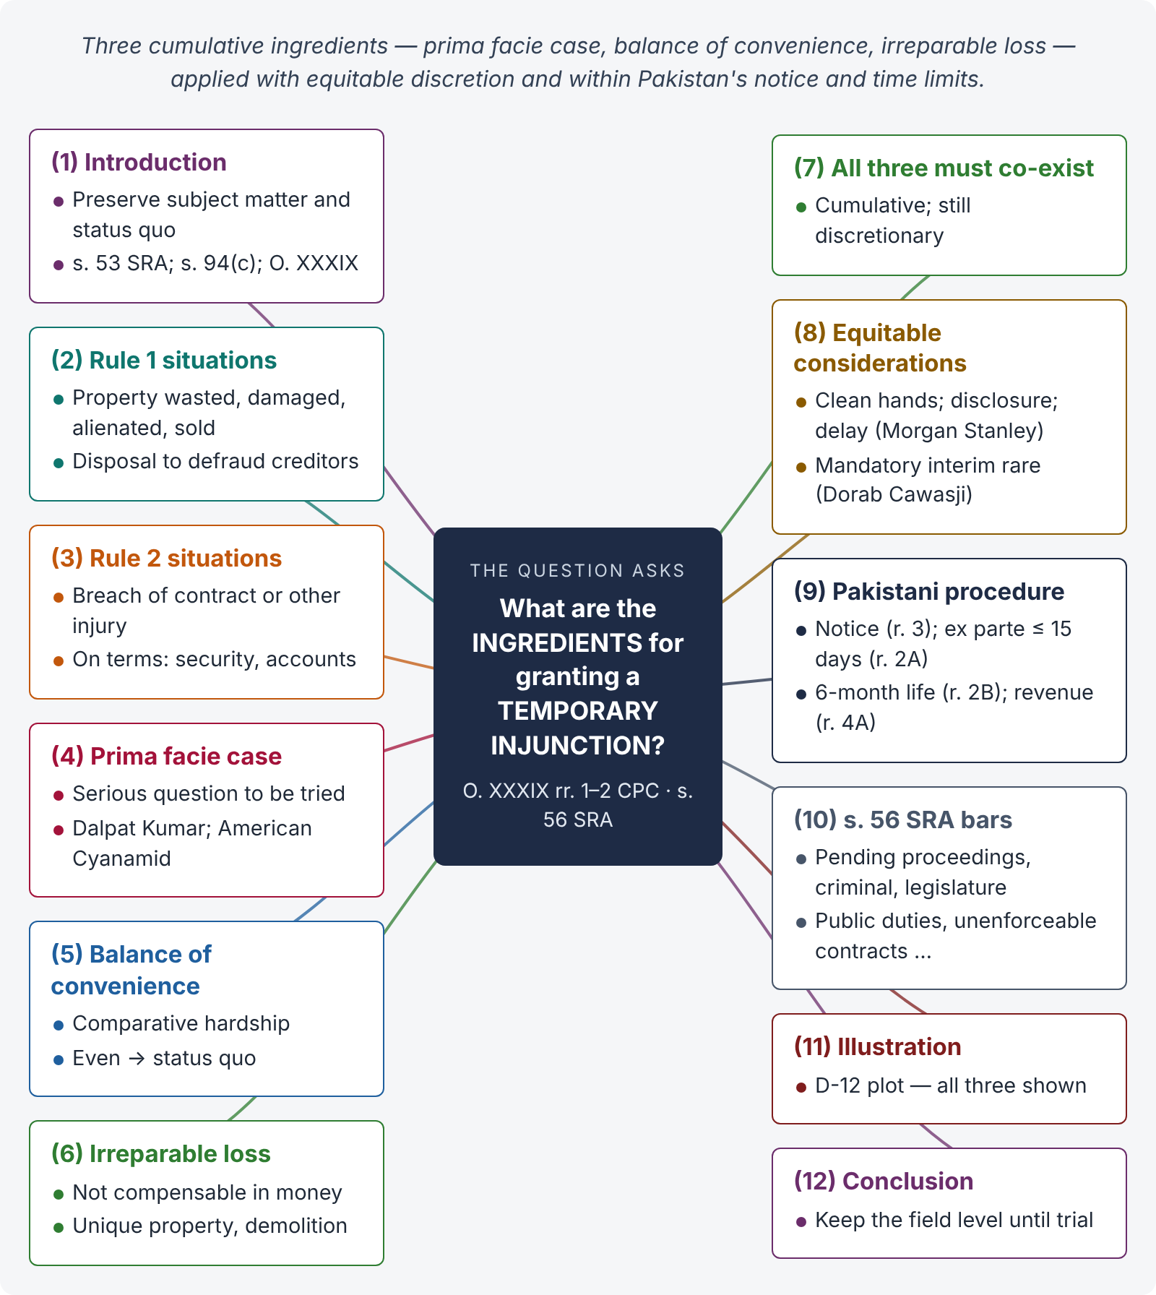
Figure 1 · The answer map: every branch is one numbered heading of the model answer below

Decoding the question
"Ingredients" — the examiner wants the three conditions (prima facie case, balance of convenience, irreparable loss), each explained with authority, plus the statutory situations in rr. 1 and 2, the equitable nature of the relief, the procedure (notice, ex parte limits) and the cases where it cannot be granted (s. 56 Specific Relief Act). An Islamabad candidate should add the Pakistani rules in O. XXXIX rr. 2A, 2B, 3 and 4A.

The model answer

1. Introduction — preserving the subject matter
A temporary injunction is an interlocutory order restraining a party from doing an act (or, rarely, directing him to do one) until the suit is decided or until further orders. Its purpose is to preserve the subject matter and the status quo, so that the final decree is not rendered useless. It is regulated by the CPC (s. 53, Specific Relief Act 1877; s. 94(c) and O. XXXIX CPC).

2. Statutory situations — rule 1

i) Property in danger
Where "any property in dispute in a suit is in danger of being wasted, damaged or alienated by any party to the suit, or wrongfully sold in execution of a decree" (r. 1(a)).

ii) Fraud on creditors
Where "the defendant threatens, or intends, to remove or dispose of his property with a view to defraud his creditors" (r. 1(b)).

3. Statutory situations — rule 2
In any suit "for restraining the defendant from committing a breach of contract or other injury of any kind, whether compensation is claimed in the suit or not", the plaintiff may apply "at any time after the commencement of the suit, and either before or after judgment", and the court may grant the injunction "on such terms as to the duration …, keeping an account, giving security or otherwise" (r. 2(1)–(2)).

4. Ingredient 1 — prima facie case
The plaintiff must show a serious question to be tried — a bona fide claim with a reasonable chance of success on the material on record. He need not prove his title at this stage; the court makes a tentative assessment (Dalpat Kumar v. Prahlad Singh, (1992) 1 SCC 719). In American Cyanamid Co. v. Ethicon Ltd. ([1975] AC 396) Lord Diplock held that it is enough that the claim is "not frivolous or vexatious" and raises a serious question to be tried.

5. Ingredient 2 — balance of convenience
The court weighs the comparative hardship: which party would suffer greater inconvenience if the injunction were granted or refused. If the risks are evenly balanced, the court preserves the status quo (American Cyanamid).

6. Ingredient 3 — irreparable loss
The injury must be such that it cannot be adequately compensated in money — e.g., sale of unique immovable property to a third party, demolition of a building, loss of goodwill. If damages would be an adequate remedy and the defendant can pay them, an injunction is usually refused.

7. All three must co-exist
The three ingredients are cumulative; the absence of any one is fatal. Even when all three exist, the relief remains discretionary.
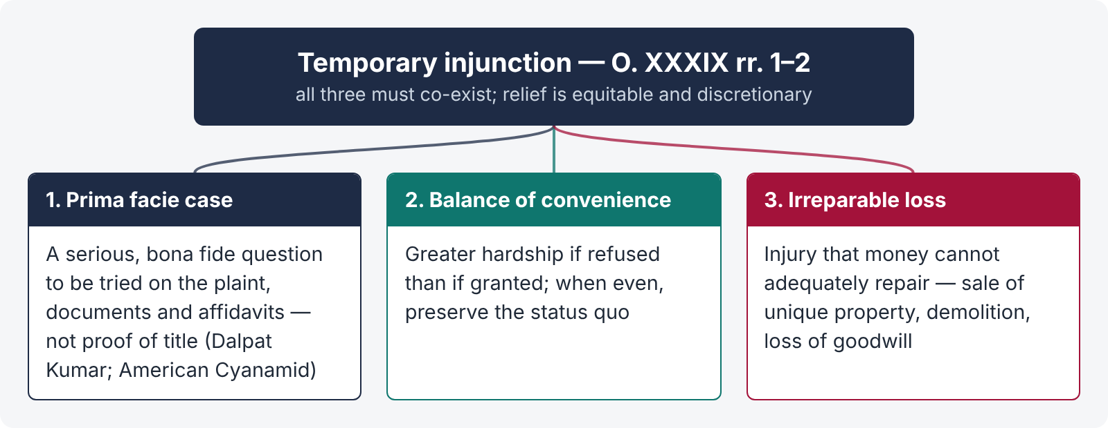
Figure 2 · The three ingredients of a temporary injunction

8. Equitable considerations

i) Clean hands and full disclosure
"He who seeks equity must do equity" and must "come with clean hands". Suppression of material facts or delay (laches) disentitles the applicant (Morgan Stanley Mutual Fund v. Kartick Das, (1994) 4 SCC 225).

ii) Mandatory interim injunctions
Granted only in rare cases on a strong prima facie case (Dorab Cawasji Warden v. Coomi Sorab Warden, (1990) 2 SCC 117).

9. Procedure — the Pakistani rules
- Notice to the opposite party "in all cases" (r. 3); may be dispensed with only where delay would defeat the object — not in bank-pledge sales or against Government / statutory bodies (except ejectment or demolition); notice to them 2–7 days.
- Ex parte injunction "shall not ordinarily exceed fifteen days" (r. 2A).
- An injunction after hearing lapses after six months unless extended with recorded reasons; report to the High Court (r. 2B).
- Injunctions concerning public revenue lapse after six months (r. 4A).
- Disobedience: attachment of property (up to one year) and civil prison up to six months (r. 2(3)–(4)).
- Appeal: O. XLIII r. 1(r); compensation for injunctions obtained on insufficient grounds — s. 95.

10. Cases in which an injunction cannot be granted — s. 56 SRA
An injunction cannot be granted: (a) to stay a judicial proceeding pending when the suit was filed (unless to prevent multiplicity); (b) to stay proceedings in a court not subordinate; (c) to restrain applications to a legislative body; (d) to interfere with the public duties of any department of Government or sovereign acts of a foreign government; (e) to stay criminal proceedings; (f) to prevent breach of a contract that would not be specifically enforced; (g) on the ground of nuisance where it is not reasonably clear that the act will be a nuisance; (h) to prevent a continuing breach in which the applicant acquiesced; (i) where equally efficacious relief is available by another usual mode (except breach of trust); (j) where the applicant's conduct disentitles him; (k) where he has no personal interest.

11. Illustration
Zubair sues for specific performance of an agreement to sell a plot in D-12 and seeks to restrain the seller from selling it to a third party. The signed agreement and admitted earnest money show a prima facie case; sale to a third party would multiply litigation and defeat the decree (balance of convenience); the plot is unique (irreparable loss). The court grants the injunction, with notice to the seller, for six months (r. 2B), on Zubair's undertaking to compensate if he fails.

12. Conclusion
A temporary injunction rests on three pillars — prima facie case, balance of convenience and irreparable loss — applied with equitable discretion and within the procedural limits of O. XXXIX (notice, 15-day ex parte limit, six-month life) and the bars of s. 56 of the Specific Relief Act. Its aim is not to decide the case but to keep the field level until the court can.

Why this answer scores
- It ties the statutory situations (rr. 1, 2) to the judge-made ingredients — two layers weak answers mix up.
- Each ingredient is supported by a leading case with a one-line ratio.
- The Pakistani procedural rules (rr. 2A, 2B, 3, 4A) show knowledge of the Islamabad text.
- The short note on s. 56 SRA is integrated, answering the companion question.

Answer 2 · Write the order of temporary injunction — public servant and official residence (LHC 2017)
AT A GLANCE · LHC CIVIL JUDGE EXAM 2017 · CIVIL LAW-II · Q. 2 · 20 MARKS
Akram being a public servant performing his function in the establishment was allotted an official residence. After six months he was transferred to a field job and was served upon with a notice to vacate the house but his children had to appear in the examination to be held after two weeks. However, under the transfer policy, he was entitled to retain the house for three years. Along with the plaint, an application for a grant of a temporary injunction was also filed. Write the order of a temporary injunction.

The answer map
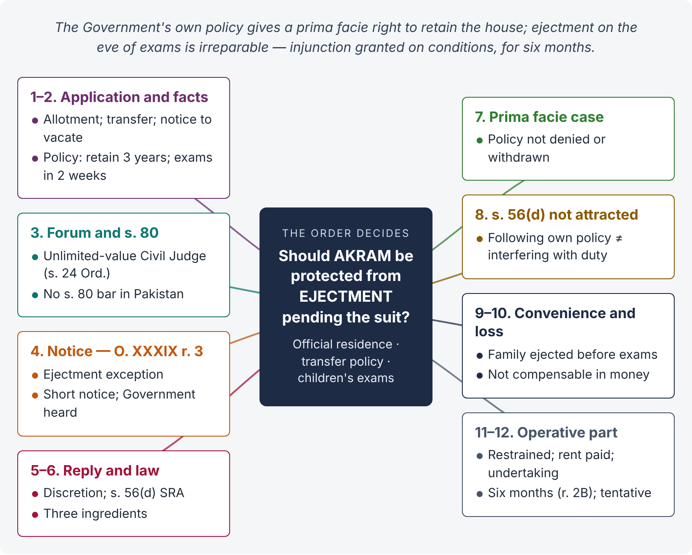
Figure 3 · The answer map: every branch is one numbered heading of the order below

Decoding the question
The examiner wants a real court order, not an essay. It must (1) be in proper format; (2) state the facts and the rival contentions; (3) apply the three ingredients; (4) deal with features special to suits against Government: the forum (s. 24 Civil Courts Ordinance), notice (O. XXXIX r. 3 — here the case involves ejectment, so notice may be dispensed with if urgent), s. 80 CPC (not a bar in Pakistan), and the bar of s. 56(d) SRA (public duties); and (5) end with a precise operative part, including duration (O. XXXIX r. 2B). The reasoning must be tentative.

The model answer
ORDER · IN THE COURT OF SENIOR CIVIL JUDGE (UNLIMITED PECUNIARY JURISDICTION), ISLAMABAD (WEST)
Civil Suit No. ___ of 2026 · Muhammad Akram v. Federation of Pakistan through Secretary, Ministry of Housing and Works, and 2 others · Suit for declaration and permanent injunction
ORDER (on the application under Order XXXIX rules 1 and 2 read with section 151 CPC)
- The application. The plaintiff, a public servant, seeks a temporary injunction restraining the defendants from ejecting him from the official residence allotted to him (House No. ___, Sector G-6/2, Islamabad) during the pendency of the suit.
- Facts in brief. The plaintiff was allotted the official residence while posted at the establishment. Six months later he was transferred to a field posting and served with a notice to vacate. He pleads that under the Government's transfer policy an officer transferred to a field job is entitled to retain his residence for three years, and that his children are to appear in their examinations within two weeks. He prays for a declaration that the notice is illegal and for a permanent injunction.
- Forum and preliminary matters. The suit is against the Federal Government and its officers in their official capacity; it has rightly been instituted in the court of a Civil Judge having unlimited pecuniary jurisdiction at district headquarters (s. 24, West Pakistan Civil Courts Ordinance 1962). The want of a notice under s. 80 CPC does not bar the suit in Pakistan; its only consequence is on costs and the time for the written statement (s. 80(2) CPC).
- Notice of the application. Under O. XXXIX r. 3 CPC, notice of an injunction application must ordinarily be given, and against Government it cannot be dispensed with except in a case "involving the ejectment of any person from … premises". This case involves ejectment; the examinations are imminent and ejectment could be effected before the defendants are heard. Notice was nevertheless issued for a short date, and the Government pleader has appeared and filed a reply. Arguments of both sides have been heard.
- Reply of the defendants. The defendants contend that allotment of official accommodation is at the discretion of the competent authority; on transfer the plaintiff lost his entitlement; another officer awaits allotment; and the court cannot interfere with the public duties of Government (s. 56(d), Specific Relief Act 1877).
- The law. A temporary injunction may be granted where the applicant shows (i) a prima facie case, (ii) that the balance of convenience is in his favour, and (iii) that he would suffer irreparable loss if it were refused (American Cyanamid Co. v. Ethicon Ltd., [1975] AC 396; Dalpat Kumar v. Prahlad Singh, (1992) 1 SCC 719). The findings are tentative.
- Prima facie case. The defendants do not deny the existence of the transfer policy; they do not show that the policy has been withdrawn or that the plaintiff falls within any exception to it. If, as pleaded, the policy entitles a transferred officer to retain his residence for three years, the notice to vacate after six months is, prima facie, contrary to the defendants' own policy. A public authority is bound to act in accordance with its policy and cannot act arbitrarily. The plaintiff has raised a serious question to be tried; a prima facie case exists.
- Section 56(d) SRA. That provision bars injunctions that "interfere with the public duties" of a Government department. Requiring a department to follow its own policy in allotment of accommodation is not interference with a public duty; the bar does not apply on the present tentative view.
- Balance of convenience. If the injunction is refused, the plaintiff and his family will be ejected days before the children's examinations, and the suit may become infructuous. If it is granted, the department is only delayed in re-allotting one house, while the plaintiff continues to pay the prescribed rent and charges. The balance of convenience is clearly in favour of the plaintiff.
- Irreparable loss. Ejectment of a family, with school-going children on the eve of examinations, and the consequent disruption of their education, cannot be compensated in money. The plaintiff would suffer irreparable loss.
- Conclusion. The application is accepted. The defendants are restrained from ejecting the plaintiff from the official residence, otherwise than in accordance with law, till the final disposal of the suit, subject to the conditions that (a) the plaintiff shall continue to pay the rent, charges and deductions applicable under the rules; (b) he shall not create any third-party interest or make structural changes; and (c) he shall file an undertaking to vacate within thirty days if the suit is dismissed. Under O. XXXIX r. 2B CPC this order shall cease to have effect after six months unless extended after hearing the parties. The observations above are tentative and shall not prejudice the trial on merits.
- The defendants to file written statement within the time allowed under s. 80(2) / O. VIII r. 1 CPC. To come up on ___ for written statement.
Announced in open court · Dated ___ · Senior Civil Judge, Islamabad (West) (seal)

Alternative outcome the examiner may expect
If the policy did not give a right of retention (e.g., it only allowed a short grace period at the department's discretion), there would be no prima facie case of a legal right; the court could at most grant limited relief — e.g., restrain ejectment until the children's examinations are over (about two weeks) on humanitarian grounds and the balance of convenience — and then dismiss the application. Mention this in one paragraph to show judicial balance.

Why this answer scores
- It is written as an order, with heading, title, numbered paragraphs and an operative part — exactly the IHC syllabus skill.
- It handles the Government angle precisely: forum (s. 24 Ordinance), s. 80 (Pakistani rule), notice exception for ejectment (O. XXXIX r. 3), and s. 56(d) SRA.
- Each of the three ingredients is applied to the facts (policy, examinations, hardship).
- The conditions in the operative part (rent, undertaking, six-month life under r. 2B) show practical judicial sense.

Answer 3 · Scope of review, revision, appeal and second appeal (LHC 2023)
AT A GLANCE · LHC CIVIL JUDGE EXAM 2023 · CIVIL LAW-II · Q. 9 · 20 MARKS
Explain the scope of review, revision, appeal and second appeal, with illustrations. Highlight the differences amongst each of the remedies mentioned above in the context of relevant provisions of the Civil Procedure Code 1908.

The answer map
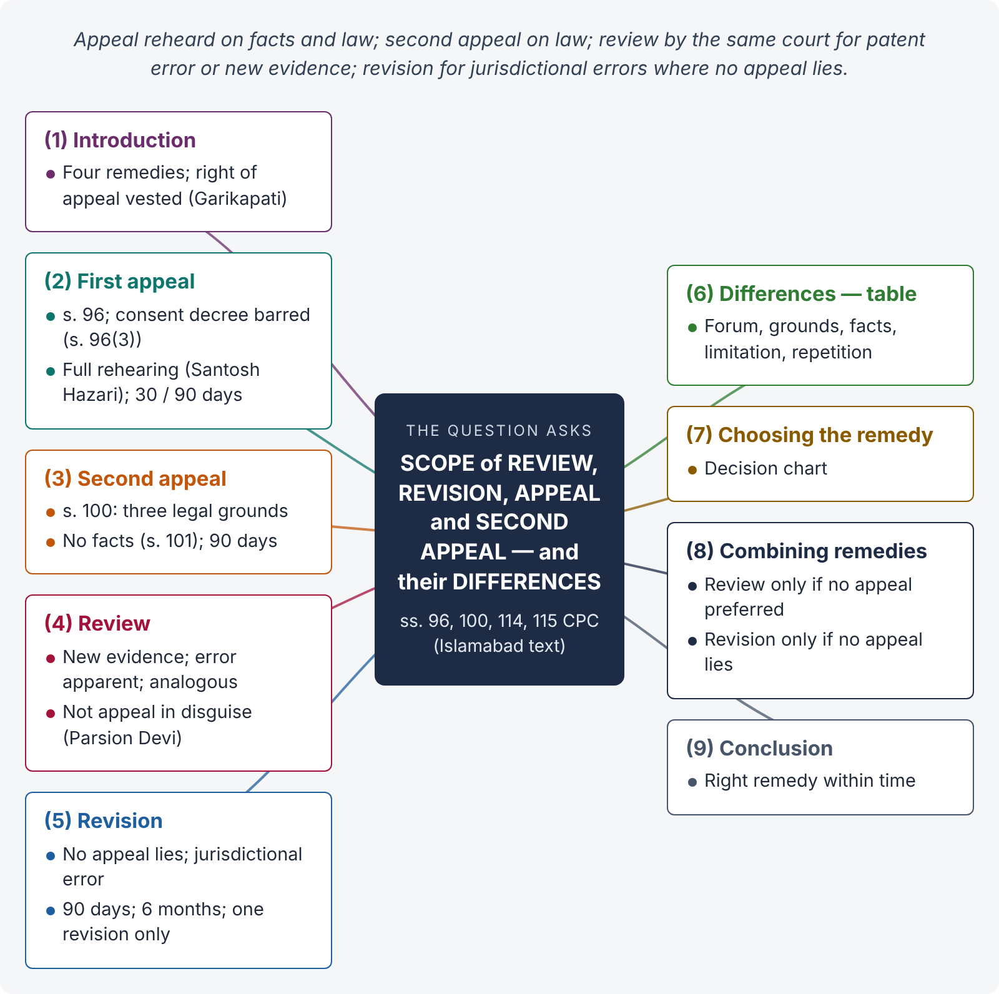
Figure 4 · The answer map: every branch is one numbered heading of the model answer below

Decoding the question
Four remedies, three tasks: scope of each (provision, grounds, forum, limitation), illustrations, and differences (a table). Use the Islamabad text of ss. 96, 100, 114 and 115, and finish with how to choose the right remedy.

The model answer

1. Introduction — four ways to challenge a decision
The CPC gives an aggrieved party four main remedies against a civil court's decision: appeal (ss. 96–108), second appeal (ss. 100–103), review (s. 114, O. XLVII) and revision (s. 115). They differ in forum, grounds, depth of scrutiny and limitation. A right of appeal is substantive and vests on the date of the suit (Garikapati Veeraya v. N. Subbiah Choudhry, AIR 1957 SC 540).

2. First appeal — scope

i) Provision
"An appeal shall lie from every decree passed by any Court exercising original jurisdiction to the Court authorized to hear appeal from the decisions of such Court" (s. 96(1)); an ex parte decree is appealable (s. 96(2)); no appeal lies from a consent decree (s. 96(3), Islamabad text).

ii) Scope
A first appeal is a continuation of the suit — a full rehearing on facts and law. The appellate court may decide finally, remand, frame issues, or take additional evidence (s. 107; O. XLI rr. 23–29), and must give findings with reasons on all points (Santosh Hazari v. Purushottam Tiwari, (2001) 3 SCC 179).

iii) Forum and time
Civil Judge → District Judge (s. 18(1) Ordinance, 2025) in 30 days (Art. 152); DJ / ADJ original → High Court (s. 17) in 90 days (Art. 156).

iv) Illustration
A Civil Judge dismisses Sana's suit for recovery of Rs. 1.2 million, disbelieving her witnesses. She appeals to the District Judge, who re-appraises the evidence and decrees the suit.

3. Second appeal — scope

i) Provision
An appeal lies to the High Court from every appellate decree on three grounds only: (a) decision contrary to law or usage having the force of law; (b) failure to determine a material issue of law; (c) substantial error or defect in procedure which may have produced error on the merits (s. 100). "No second appeal shall lie except on the grounds mentioned in section 100" (s. 101).

ii) Scope
No re-appraisal of facts; findings of fact are final unless based on no evidence, misreading or non-reading of evidence, or inadmissible evidence (errors of law). The High Court may decide issues of fact in the s. 100 situations (s. 103). Value limit as prescribed (s. 102). 90 days.

iii) Illustration
The District Judge, in appeal, decrees possession by ignoring a registered sale deed proved on record. That is non-reading of evidence — a ground under s. 100(a); a second appeal lies.

4. Review — scope

i) Provision
Any person aggrieved by a decree or order from which an appeal is allowed but not preferred, or from which no appeal is allowed, may apply for review "to the Court which passed the decree or made the order" (s. 114).

ii) Grounds
(1) New and important matter or evidence not available despite due diligence; (2) mistake or error apparent on the face of the record; (3) any other sufficient reason — analogous to the first two (O. XLVII r. 1; Moran Mar Basselios Catholicos v. Mar Poulose Athanasius, AIR 1954 SC 526).

iii) Scope
Review is not an appeal in disguise; the error must be self-evident, not one requiring a long process of reasoning (Parsion Devi v. Sumitri Devi, (1997) 8 SCC 715). Same judge (r. 2, r. 5); notice before grant (r. 4); rejection not appealable (r. 7); no review of review (r. 9). 90 days (Art. 173).

iv) Illustration
A Civil Judge dismisses a suit as time-barred, overlooking that the plaint pleads acknowledgment under s. 19 Limitation Act supported by an exhibited letter. The error is apparent on the record — review lies.

5. Revision — scope

i) Provision (Islamabad text, 2023)
The High Court may call for the record of "any case which has been decided by any Court subordinate … and in which no appeal lies thereto", and interfere if the court (a) exercised a jurisdiction not vested in it, (b) failed to exercise a jurisdiction so vested, or (c) acted illegally or with material irregularity (s. 115(1)).

ii) Scope
Supervisory and discretionary — limited to jurisdictional errors (Keshardeo Chamria v. Radha Kissen Chamria, AIR 1953 SC 23); "case decided" includes interlocutory orders (Major S.S. Khanna v. Brig. F.J. Dillon, AIR 1964 SC 497). Islamabad provisos: copies of pleadings and orders; decision without calling for the record unless reasons recorded; filed within 90 days; decided within six months. The District Court has the same power within its appellate limits (s. 115(2)); only one revision to either court (s. 115(3)); the High Court cannot revise the District Court's revisional order (s. 115(4)).

iii) Illustration
A Civil Judge refuses to return a plaint for a partition suit of land in another district. No appeal lies (only an order returning a plaint is appealable — O. XLIII r. 1(a)); the court exercised a jurisdiction not vested in it — revision lies.

6. Differences — the comparison table
Basis | Appeal | Second appeal | Review | Revision
Provision | s. 96; O. XLI | ss. 100–103; O. XLII | s. 114; O. XLVII | s. 115
Forum | Superior court | High Court | Same court / judge | High Court or District Court
Against | Original decree; listed orders (s. 104) | Appellate decree | Decree / order not appealed or not appealable | Case decided, no appeal lies
Grounds | Any error of fact or law | 3 legal grounds only | New evidence; error apparent; analogous | Jurisdictional error; illegality; material irregularity
Nature | Right; rehearing | Right; limited to law | Narrow statutory power | Discretionary supervision
Facts re-examined? | Yes | No (except s. 103) | No | No (except misreading / non-reading)
Limitation | 30 / 90 days | 90 days | 90 days | 90 days (Islamabad)
Bar on repetition | — | — | No review of review | One revision only

7. Choosing the remedy
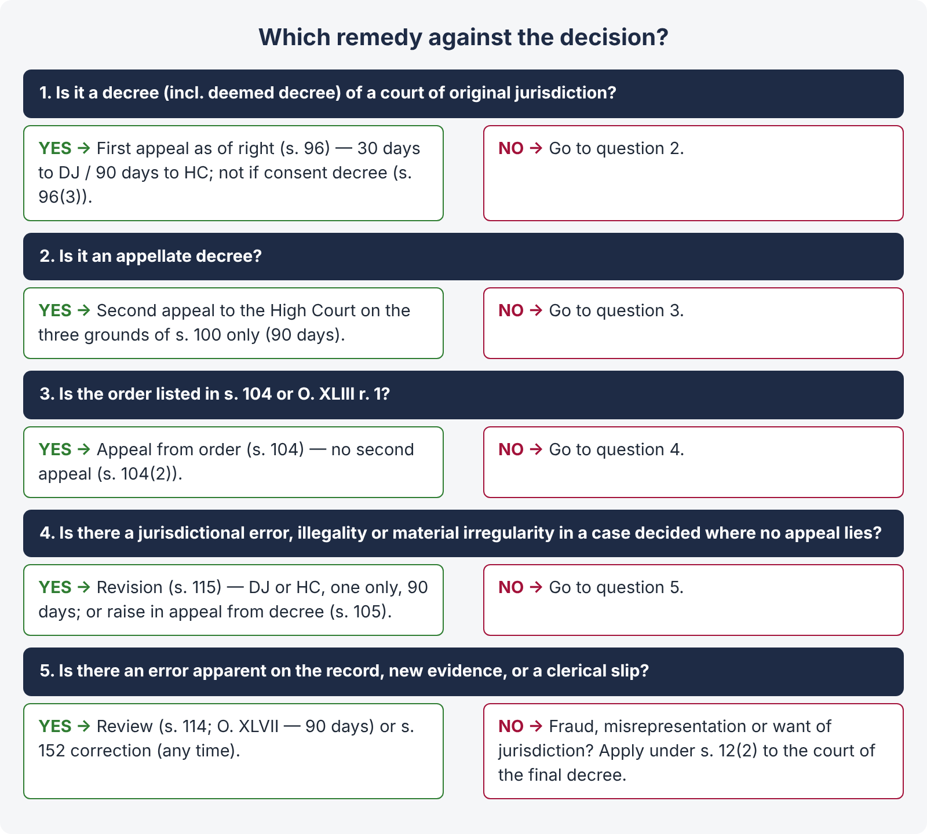
Figure 5 · Choosing the right remedy against a civil court's decision

8. Can remedies be combined?
A party cannot pursue review and appeal on the same ground simultaneously — review lies only where no appeal has been preferred (s. 114(a)), and once an appeal is decided on merits, the decree merges in the appellate decree. Revision lies only where no appeal lies; it is not an alternative to an available appeal. Errors in non-appealable interlocutory orders may also be raised in the appeal from the final decree (s. 105).

9. Conclusion
Appeal corrects any error by a full rehearing; second appeal corrects errors of law in appellate decrees; review lets the same court correct a patent error or consider genuinely new evidence; revision lets the superior court correct jurisdictional errors where no appeal lies. Choosing the correct remedy — and filing it within time — is as important as having a good case.

Why this answer scores
- Each remedy is explained under the same four sub-heads — provision, grounds / scope, forum and time, illustration — making comparison easy.
- The Islamabad text of ss. 96(3) and 115 (90 days, six months, one revision) is used.
- The table answers "highlight the differences" in one view, and the decision chart shows practical judgment.
- Leading cases support each remedy's limits.

Answer 4 · Review (s. 114) and amendment of judgments (s. 152) (KPHC 2026)
AT A GLANCE · KP HIGH COURT 2026 · CIVIL LAW-I · Q. 4 · 20 MARKS
Differentiate between a civil court's power of 'review' under section 114 CPC, 1908, from the powers of a civil court to 'amend judgments, decrees and orders' under section 152 CPC, 1908.

The answer map
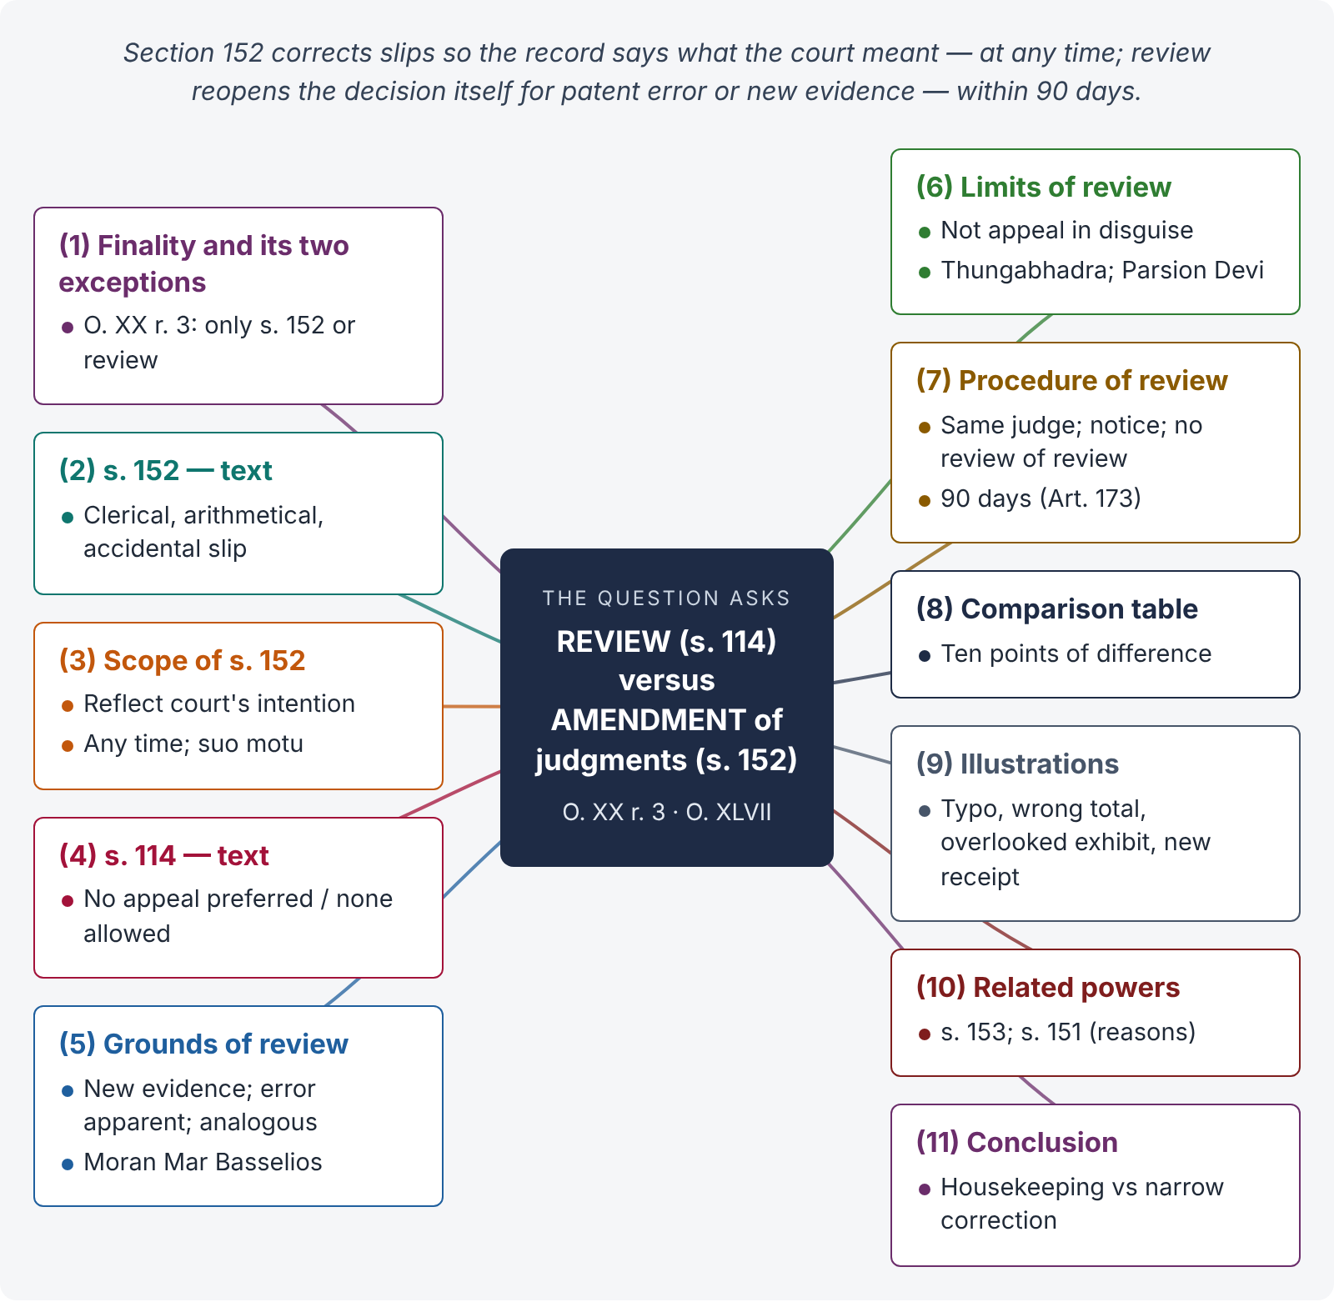
Figure 6 · The answer map: every branch is one numbered heading of the model answer below

Decoding the question
Two powers by which a court revisits its own decision. The examiner wants: the text of each, its purpose, its scope and limits, procedure and time, and a clear comparison — with illustrations showing where one ends and the other begins. Mention the principle that a signed judgment "shall not afterwards be altered or added to, save as provided by section 152 or on review" (O. XX r. 3).

The model answer

1. Introduction — finality and its two exceptions
Once a judgment is pronounced and signed, the court becomes functus officio — its job is done. "The judgment … when once signed, shall not afterwards be altered or added to, save as provided by section 152 or on review" (O. XX r. 3). The CPC thus allows only two ways for a court to revisit its own judgment: correction (s. 152) and review (s. 114).

2. Section 152 — the text
"Clerical or arithmetical mistakes in judgments, decrees or orders or errors arising therein from any accidental slip or omission may at any time be corrected by the Court either of its own motion or on the application of any of the parties."

3. Scope of s. 152

i) What it covers
(a) Clerical mistakes — typing errors in names, numbers, dates, khasra numbers; (b) arithmetical mistakes — wrong totals or interest calculations; (c) accidental slips or omissions — e.g., the court intended to award costs as stated in the judgment but the decree omits them.

ii) What it does not cover
It cannot be used to change the decision, add a relief not granted, correct an error of law or judgment, or rewrite reasoning. The test: does the correction make the record say what the court actually intended at the time? (Actus curiae neminem gravabit — a slip of the court must not prejudice a party.)

iii) Time and initiative
"At any time" — even after appeal or execution has begun; by the court suo motu or on application.

4. Section 114 and Order XLVII — the text
"Any person considering himself aggrieved by a decree or order from which (a) an appeal is allowed by this Code, but from which no appeal has been preferred; or (b) no appeal is allowed by this Code, may apply for a review of judgment to the Court which passed the decree or made the order" (s. 114, Islamabad text).

5. Grounds of review — O. XLVII r. 1
(1) Discovery of new and important matter or evidence which, after due diligence, was not within the applicant's knowledge or could not be produced; (2) mistake or error apparent on the face of the record; (3) any other sufficient reason — analogous to the first two (Moran Mar Basselios Catholicos v. Mar Poulose Athanasius, AIR 1954 SC 526).

6. Limits of review
Review is not an appeal in disguise; an error that needs a long process of reasoning or a debatable point is not "apparent" (Thungabhadra Industries v. Govt. of A.P., AIR 1964 SC 1372; Parsion Devi v. Sumitri Devi, (1997) 8 SCC 715).

7. Procedure of review
Application to the same court (and, for grounds other than new evidence or clerical errors, the same judge — r. 2); notice to the opposite party before grant, strict proof of new evidence (r. 4); rejection not appealable, grant objectionable by appeal (r. 7; O. XLIII r. 1(w)); re-hearing after grant (r. 8); no review of a review (r. 9); limitation 90 days (Art. 173).

8. Comparison
Basis | Amendment — s. 152 | Review — s. 114 / O. XLVII
Purpose | Make the record reflect what the court intended | Re-open the decision itself for a legal reason
Errors covered | Clerical, arithmetical, accidental slip or omission | New evidence; error apparent; analogous sufficient reason
Effect on decision | None — decision unchanged | May alter or reverse the decision
Who may move | Court suo motu or any party | Only a person aggrieved, by application
Time | At any time | 90 days (Art. 173)
Judge | Any successor may correct | Same judge (unless unavailable)
Notice / hearing | Desirable, not always required for patent slips | Notice mandatory before granting
Remedy against order | Appeal / revision as the case may be | Rejection not appealable; grant appealable (O. XLIII r. 1(w))
Repetition | Any time a slip is found | No review of review (r. 9)

9. Illustrations
- The judgment decrees Rs. 750,000, but the decree sheet says Rs. 75,000 → s. 152 (clerical).
- The court computed interest at 10% for three years as Rs. 150,000 on Rs. 1 million; the correct figure is Rs. 300,000 → s. 152 (arithmetical).
- The court dismissed the suit as time-barred, overlooking s. 14 Limitation Act exclusion clearly shown by an exhibited order of return of plaint → review (error apparent).
- After decree, the defendant discovers a registered receipt of payment which, despite due diligence, he could not trace earlier → review (new evidence, strict proof).
- The losing party argues that the court wrongly believed a witness → neither; remedy is appeal.

10. Related powers
- s. 153: general power to amend any defect or error in proceedings to decide the real question.
- Appellate correction: an appellate court may correct slips in its own decree under s. 152.
- Inherent power (s. 151): to recall an order passed by the court's own mistake (e.g., without notice), with recorded reasons in Islamabad.

11. Conclusion
Section 152 is a housekeeping power to correct slips so that the record speaks the truth of what the court decided; review is a narrow corrective jurisdiction to reconsider the decision itself for patent error or genuinely new evidence. One leaves the decision untouched; the other may overturn it — and both stop short of an appeal.

Why this answer scores
- It starts from O. XX r. 3 — the rule that makes s. 152 and review the only exceptions to finality.
- The comparison table covers ten points of difference.
- Five short illustrations sharply separate slips, patent errors and appealable errors.
- Leading cases mark the limits of review.

Answer 5 · Interpleader suits — how and where instituted, and their rules (KPHC 2026)
AT A GLANCE · KP HIGH COURT 2026 · CIVIL LAW-I · Q. 1 · 20 MARKS
What do you mean by interpleader suit? How and where should it be instituted? Explain in detail its rules in the light of different provisions of CPC, 1908. (Also LHC 2017 short note: "Interpleader suit".)

The answer map
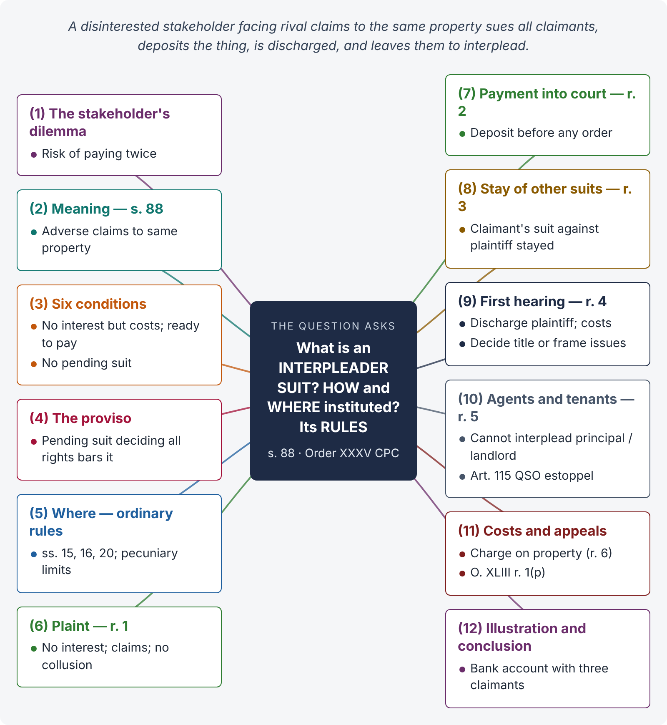
Figure 7 · The answer map: every branch is one numbered heading of the model answer below

Decoding the question
Three parts: meaning (s. 88 and its conditions), how and where (plaint contents under O. XXXV r. 1, payment into court, ordinary rules of place of suing and pecuniary jurisdiction), and rules (O. XXXV rr. 1–6, including the agents / tenants bar, appeals and costs). Add illustrations and the rationale.

The model answer

1. Introduction — the stakeholder's dilemma
Sometimes a person holds money or property in which he claims no interest, but two or more persons claim it against each other. If he pays one, the other may sue him; he risks paying twice. The interpleader suit lets him bring all the claimants before the court, deposit the thing, be discharged, and leave the claimants to "interplead" — to fight among themselves.

2. Meaning — s. 88
"Where two or more persons claim adversely to one another the same debt, sum of money or other property, moveable or immoveable, from another person, who claims no interest therein other than for charges or costs and who is ready to pay or deliver it to the rightful claimant, such other person may institute a suit of interpleader against all the claimants for the purpose of obtaining a decision as to the person to whom the payment or delivery shall be made and of obtaining indemnity for himself."

3. Essential conditions
- Two or more claimants;
- claiming adversely to one another (not jointly);
- the same debt, money or property, movable or immovable;
- from a person who claims no interest except charges or costs;
- who is ready to pay or deliver it to the rightful claimant;
- no pending suit in which the rights of all parties can properly be decided (proviso).

4. The bar of a pending suit — proviso to s. 88
"Where any suit is pending in which the rights of all parties can properly be decided, no such suit of interpleader shall be instituted." The interpleader suit is a device to avoid multiplicity; it cannot itself create it.

5. Where to institute
The CPC prescribes no special forum: the ordinary rules apply — the court of the lowest grade competent (s. 15) within whose local limits the defendants (claimants) reside or the cause of action arose (s. 20), or where the immovable property is situate (s. 16), within the court's pecuniary limits (value of the property or money). In Islamabad, a Civil Judge with the necessary pecuniary powers.

6. How to institute — the plaint (O. XXXV r. 1)
Besides the usual particulars (O. VII r. 1), the plaint must state: "(a) that the plaintiff claims no interest in the subject-matter in dispute other than for charges or costs; (b) the claims made by the defendants severally; and (c) that there is no collusion between the plaintiff and any of the defendants." All the claimants are made defendants.

7. Payment into court — r. 2
"Where the thing claimed is capable of being paid into Court or placed in the custody of the Court, the plaintiff may be required to so pay or place it before he can be entitled to any order in the suit." This guarantees that the stakeholder is genuinely neutral.

8. Stay of other suits — r. 3
Where any defendant is already suing the plaintiff about the same subject matter, the court in which that suit is pending shall, on being informed by the interpleader court, stay it as against the plaintiff; his costs may be provided for.

9. Procedure at the first hearing — r. 4
The court may: (a) declare the plaintiff discharged from all liability to the defendants, award him costs and dismiss him from the suit; or (b) retain all parties till final disposal if justice or convenience requires. Where admissions or evidence allow, it adjudicates title at once (r. 4(2)); otherwise it frames issues between the claimants and may make a claimant the plaintiff in place of or in addition to the original plaintiff, and tries the suit in the ordinary manner (r. 4(3)).

10. Agents and tenants cannot interplead — r. 5
"Nothing in this Order shall be deemed to enable agents to sue their principals, or tenants to sue their landlords, for the purpose of compelling them to interplead with any persons other than persons making claim through such principals or landlords." An agent or tenant who holds through a principal or landlord cannot deny that person's title by setting up a stranger's adverse claim (the estoppel of Art. 115 Qanun-e-Shahadat). Illustrations: (a) A deposits jewels with his agent B; C claims they were wrongfully taken from him — B cannot interplead A and C. (b) A pledges the jewels to C through B, and A and C dispute whether C's debt is paid — B can interplead A and C (C claims through A).

11. Costs and appeals — r. 6, O. XLIII
Where the suit is properly instituted, the plaintiff's costs may be given as a charge on the thing claimed (r. 6). Orders under O. XXXV rr. 3, 4 and 6 are appealable (O. XLIII r. 1(p)); the final decree between the claimants is appealable under s. 96.

12. Illustration and conclusion
A bank in Blue Area holds Rs. 4 million in a deceased customer's account; his widow (as nominee), his brother (under an alleged gift) and a decree-holder creditor all claim it. No suit is pending in which all claims can be decided. The bank files an interpleader suit, deposits the money, and is discharged at the first hearing; the court frames issues among the three claimants.
The interpleader suit protects an honest, disinterested holder from double vexation, avoids multiplicity of suits, and lets the real disputants have their rights decided in one proceeding — subject to its strict conditions and the bar on agents and tenants.

Why this answer scores
- All three parts of the question — meaning, how / where, rules — are answered under separate headings.
- Every rule of O. XXXV (rr. 1–6) and both parts of s. 88 (including the proviso) are covered.
- The agents / tenants bar is explained with the Code's own illustrations and its estoppel rationale.
- The answer correctly notes that forum is governed by ordinary rules (ss. 15–20), a point many candidates miss.

Answer 6 · Summary suits — leave to defend and denial of consideration (LHC 2023)
AT A GLANCE · LHC CIVIL JUDGE EXAM 2023 · CIVIL LAW-II · Q. 8 · 20 MARKS
Suits under Order XXXVII of the Civil Procedure Code 1908 envisage regular trial after leave to appear and defend is granted, upon finding need to adjudicate triable question(s). Whether assertion of denial of consideration by the defendant constitutes a triable question of law, and on whom the onus lies to prove absence of consideration.

The answer map
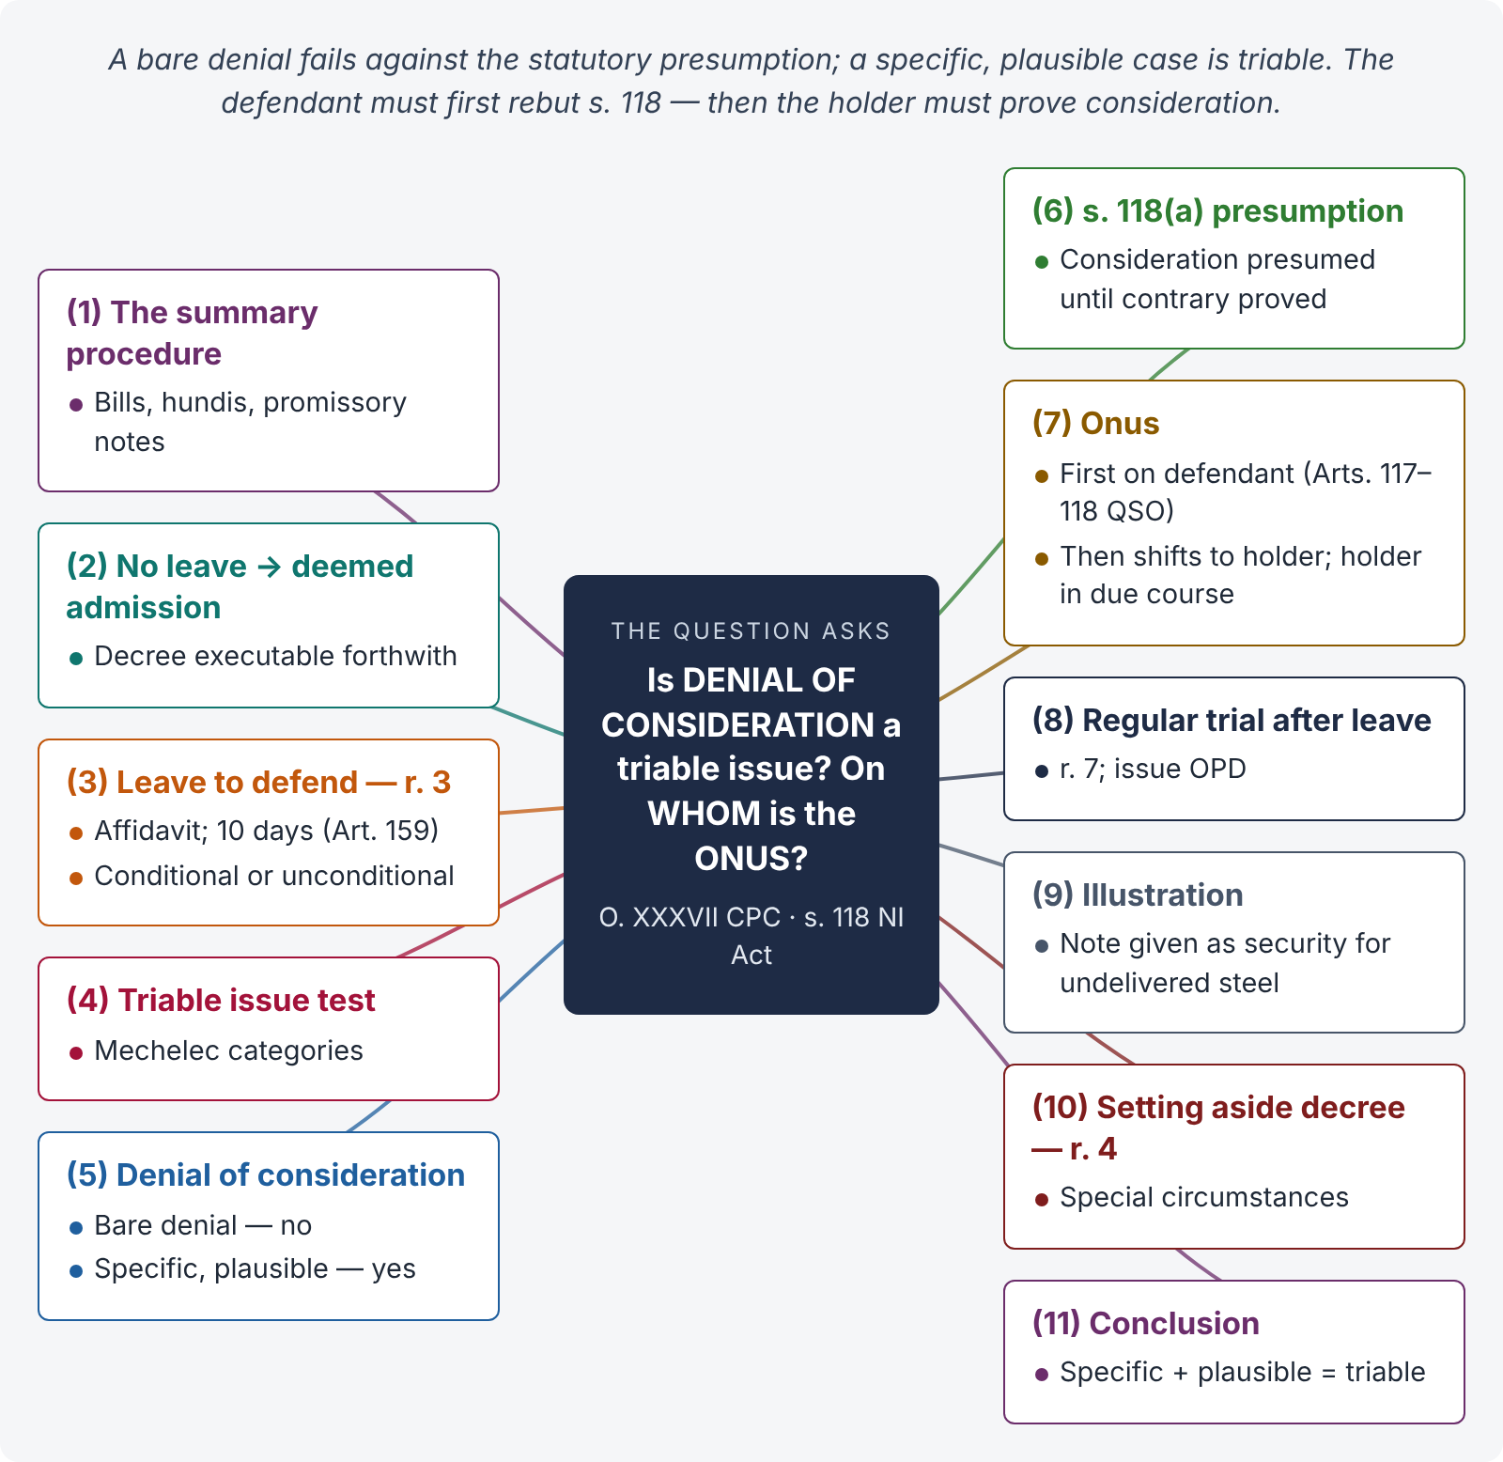
Figure 8 · The answer map: every branch is one numbered heading of the model answer below

Decoding the question
The examiner wants: (1) the nature of O. XXXVII and the leave requirement; (2) the test for leave ("triable issue"); (3) whether denial of consideration is a triable issue — the answer depends on how it is pleaded; (4) the onus — read with s. 118 of the Negotiable Instruments Act (presumption of consideration) and Arts. 117–118 Qanun-e-Shahadat; and (5) the consequences (conditional or unconditional leave; regular trial).

The model answer

1. Introduction — the summary procedure
Order XXXVII provides a summary procedure for suits "upon bills of exchange, hundis or promissory notes" (r. 2(1)) in the High Court, the District Court and other notified courts (r. 1). Its object is speedy recovery on commercial instruments: the defendant "shall not appear or defend the suit unless he obtains leave from a Judge" (r. 2(2)).

2. Consequence of not obtaining leave
If the defendant does not obtain leave, "the allegations in the plaint shall be deemed to be admitted, and the plaintiff shall be entitled to a decree" for the principal, interest and costs (r. 2(2)); the decree "may be executed forthwith" (r. 2(3)).

3. Leave to defend — r. 3
"The Court shall, upon application by the defendant, give leave to appear and to defend the suit, upon affidavits which disclose such facts as would make it incumbent on the holder to prove consideration, or such other facts as the Court may deem sufficient to support the application" (r. 3(1)). Leave may be unconditional or conditional — payment into court, security, framing of issues (r. 3(2)). The application must be made within ten days of service of summons (Art. 159, Limitation Act); s. 5 of the Limitation Act applies (r. 3(3)).

4. The test — triable issue
Following Mechelec Engineers v. Basic Equipment Corporation ((1976) 4 SCC 687): (a) a good defence → unconditional leave; (b) a triable issue showing a fair, bona fide defence → unconditional leave ordinarily; (c) triable issue but doubtful genuineness → conditional leave; (d) sham or moonshine defence → leave refused; (e) admitted part → deposit required.

5. Is denial of consideration a triable question?

i) The text of r. 3 itself
Rule 3(1) speaks of facts "as would make it incumbent on the holder to prove consideration". So a plea of want of consideration is precisely the kind of defence the rule contemplates — if it is supported by facts.

ii) Bare denial — not enough
A bald, general denial ("no consideration was received") raises no triable issue, because the law presumes consideration (s. 118(a), NI Act). The affidavit must disclose specific facts showing why there was no consideration.

iii) Specific, plausible facts — triable
A plausible case — e.g., the note was given as security for a transaction that never materialised, or the consideration failed, supported by documents or circumstances — raises a triable issue of fact (or a mixed question), on which leave should be granted, conditionally if the defence looks doubtful.

iv) A question of law?
Whether consideration passed is primarily a question of fact; whether the facts alleged, if proved, amount to want or failure of consideration in law is a mixed question. Either way, if it is real, it is "triable".

6. The statutory presumption — s. 118(a) NI Act
"Until the contrary is proved, the following presumptions shall be made: (a) of consideration — that every negotiable instrument was made or drawn for consideration, and that every such instrument, when it has been accepted, endorsed, negotiated or transferred, was accepted, endorsed, negotiated or transferred for consideration."

7. On whom the onus lies
- Initially on the defendant — because of the presumption in s. 118(a), the defendant who asserts want of consideration must rebut it ("until the contrary is proved"). Under Arts. 117–118 QSO, the burden lies on the person who asserts.
- The defendant may discharge this burden by direct evidence or by circumstances that make the non-existence of consideration probable; a mere denial in the witness box is not enough.
- Once he does so, the onus shifts to the plaintiff to prove that consideration was in fact given.
- A holder in due course (who took the instrument for value, in good faith, before maturity — s. 9 NI Act) is protected against the defence of want of consideration between prior parties.

8. What happens after leave — regular trial
Once leave is granted, "the procedure in suits hereunder shall be the same as the procedure in suits instituted in the ordinary manner" (r. 7): written statement, issues (including "Whether the promissory note was executed without consideration? OPD"), evidence and judgment.

9. Illustration
Rafiq sues Hamid under O. XXXVII on a promissory note for Rs. 2 million. Hamid's affidavit says he signed the note as security for a supply of steel which Rafiq never delivered, and annexes Rafiq's letter admitting non-supply. This discloses facts making it "incumbent on the holder to prove consideration" — unconditional leave should be granted. Had Hamid merely said "no consideration", leave would be refused (or granted only on deposit).

10. Setting aside a decree — r. 4
Even after a decree, the court may, under special circumstances (e.g., no proper service of the Form No. 4 summons), set it aside and grant leave to defend.

11. Conclusion
Denial of consideration is a triable issue only when it is specific and plausible; a bare denial is defeated by the presumption of s. 118(a) NI Act. The onus initially lies on the defendant to rebut the presumption; once he shows facts making want of consideration probable, the plaintiff must prove consideration. Leave is then granted — unconditionally or on terms — and the suit proceeds as a regular trial.

Why this answer scores
- It answers both questions directly — triable issue? onus on whom? — with reasons.
- It uses the text of O. XXXVII r. 3(1) ("make it incumbent on the holder to prove consideration") as the key.
- It links to s. 118 NI Act and Arts. 117–118 QSO — showing integrated knowledge.
- The Mechelec categories and a crisp illustration show practical judgment.

Answer 7 · Guardian ad litem; deciding minority; decree against an unrepresented minor (LHC 2023)
AT A GLANCE · LHC CIVIL JUDGE EXAM 2023 · CIVIL LAW-II · Q. 7 · 20 MARKS
Explain the term 'Guardian Ad Litem'. Whether the court, before whom lis is brought involving minor, is competent to decide the dispute regarding factum of minority of the minor. Discuss the effect of any decree passed, affecting the rights of the minor, without the appointment of guardian, in the context of Order XXXII of Civil Procedure Code 1908.

The answer map
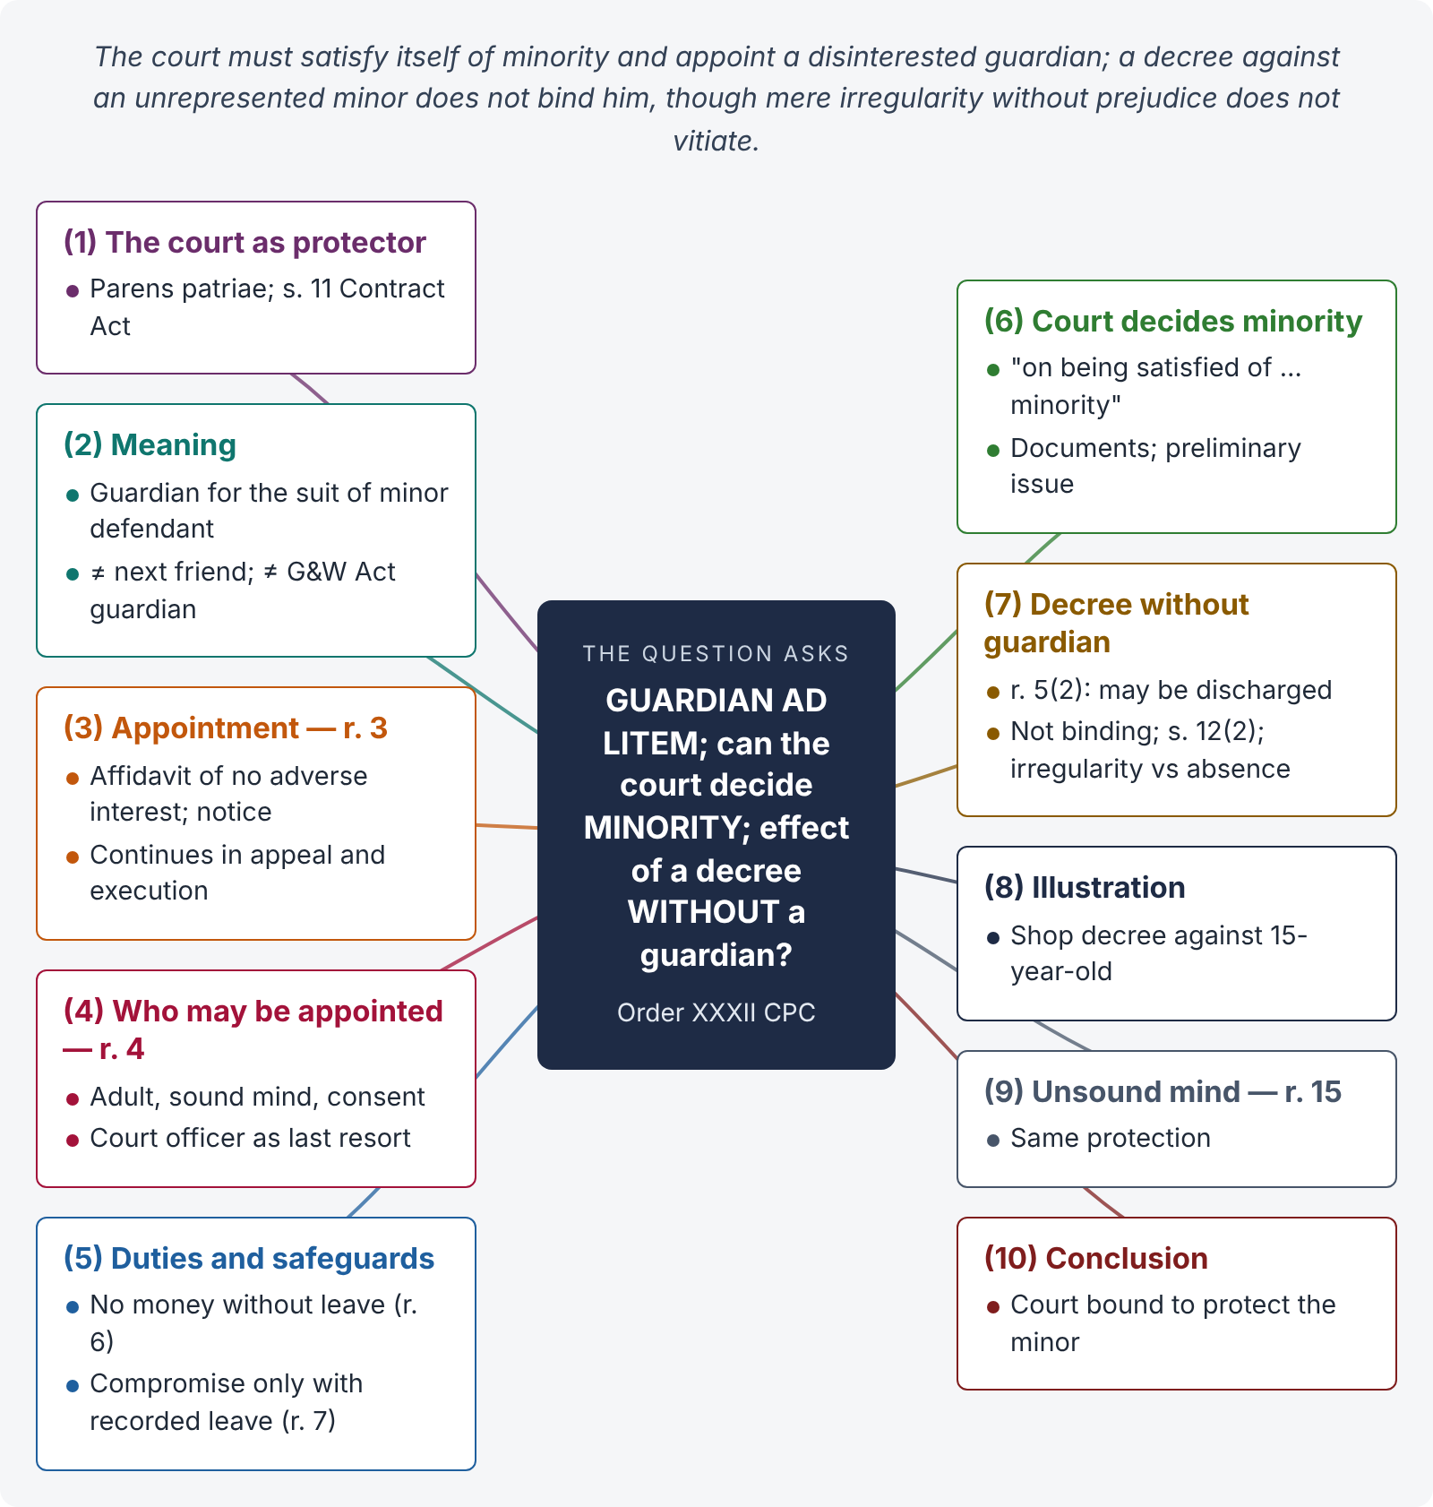
Figure 9 · The answer map: every branch is one numbered heading of the model answer below

Decoding the question
Three questions: (1) meaning of guardian ad litem and the rules on his appointment; (2) whether the court itself decides minority — answer from O. XXXII r. 3(1) ("on being satisfied of the fact of his minority"); (3) effect of a decree passed without a guardian — O. XXXII r. 5(2) and general principles (decree not binding on the minor; remedies). Frame it within the parens patriae duty of the court.

The model answer

1. Introduction — the court as protector
A minor (a person under 18 — Majority Act 1875) cannot understand or protect his legal rights; he cannot even contract (s. 11, Contract Act). The court therefore acts as *parens patriae* — the protector of those who cannot protect themselves. Order XXXII ensures that a minor is always represented in litigation by a person without conflicting interest.

2. Meaning — guardian ad litem
A guardian ad litem ("guardian for the suit") is a person appointed by the court to represent and defend a minor defendant in a particular suit and all proceedings arising from it (O. XXXII r. 3). A minor plaintiff sues through a next friend (r. 1). A guardian ad litem is different from a guardian of the person or property appointed under the Guardians and Wards Act 1890, though such a guardian is preferred for appointment (r. 4(2)).

3. Appointment — O. XXXII r. 3
"Where the defendant is a minor, the Court, on being satisfied of the fact of his minority, shall appoint a proper person to be guardian for the suit for such minor" (r. 3(1)). The application (by the plaintiff or on the minor's behalf) is supported by an affidavit that the proposed guardian has no interest adverse to the minor and is fit (r. 3(3)); notice must be given to the minor and to his court-appointed guardian, or father / natural guardian, or the person in whose care he is (r. 3(4)). The appointment continues through appeal, revision and execution (r. 3(5)).

4. Who may be appointed — r. 4
Any person of sound mind who has attained majority, whose interest is not adverse to the minor, and who is not a plaintiff in the suit; a court-appointed guardian has preference; no one without his consent; if no fit person is willing, the court may appoint one of its officers at the parties' cost (r. 4(1)–(4)).

5. Duties and safeguards
The guardian must defend the minor's interests with due care; he cannot receive money for the minor without leave (r. 6) or enter a compromise without the express leave of the court recorded in the proceedings — otherwise the compromise is voidable at the minor's instance (r. 7). He may be removed for adverse interest, neglect or misconduct (rr. 9, 11).

6. Can the court decide the factum of minority? — Yes

i) The text
Rule 3(1) requires the court to be "satisfied of the fact of his minority" before appointing a guardian — so the court itself determines whether the party is a minor.

ii) How
On the material produced — B-form / CNIC, birth certificate, school and matriculation records, medical opinion on age — and, if disputed, by framing a preliminary issue and recording evidence. The court is competent because the question is incidental to the conduct of the suit before it; no separate proceeding is needed. The finding governs representation in that suit.

7. Effect of a decree without a guardian

i) The rule in r. 5(2)
"Every order made in a suit or on any application, before the Court in or by which a minor is in any way concerned or affected, without such minor being represented by a next friend or guardian for the suit, as the case may be, may be discharged, and, where the pleader of the party at whose instance such order was obtained knew, or might reasonably have known, the fact of such minority, with costs to be paid by such pleader."

ii) The principle
A minor who was never represented was, in law, never before the court. A decree passed against him does not bind him; as against the minor it is treated as void / a nullity, and he may avoid it.

iii) Remedies of the minor
(a) Application to discharge / set aside the decree under O. XXXII r. 5(2) read with s. 151; (b) application under s. 12(2) CPC (want of jurisdiction over his person, or fraud where his minority was concealed); (c) appeal treating the decree as a nullity; (d) on attaining majority, resist execution on the ground that the decree is not binding on him.

iv) Irregularity vs absence of representation
Distinguish total absence of a guardian (decree not binding) from a mere irregularity in appointment (e.g., notice under r. 3(4) not given to the father, but a fit guardian was appointed and defended properly). Courts have generally upheld decrees in the second situation if the minor's interests were fully protected and no prejudice resulted, because the purpose of Order XXXII was achieved.

8. Illustration
Sajid sues Bilal, aged 15, for possession of a shop inherited by Bilal, describing him as an adult. No guardian is appointed; an ex parte decree is passed. Bilal's mother later shows his B-form. The decree is not binding on Bilal: it may be discharged under O. XXXII r. 5(2), with costs against the plaintiff's pleader if he knew of the minority; Bilal may also apply under s. 12(2). If, instead, the court had appointed Bilal's uncle as guardian (with no adverse interest) who defended fully, but notice to the mother under r. 3(4) was not issued, the decree would ordinarily stand, absent prejudice.

9. Persons of unsound mind — r. 15
Rules 1–14 apply equally to persons adjudged of unsound mind, and to persons found by the court on inquiry to be incapable of protecting their interests by reason of mental infirmity.

10. Conclusion
A guardian ad litem is the court-appointed voice of a minor defendant. The court is competent — indeed bound — to decide the factum of minority before appointing him (r. 3(1)). A decree passed against a minor without any guardian is not binding on him and may be discharged (r. 5(2)) or challenged under s. 12(2), while a mere procedural irregularity in an otherwise proper representation does not vitiate the decree if no prejudice is shown. The whole scheme gives effect to the court's parens patriae duty.

Why this answer scores
- All three questions are answered separately, each from the text of Order XXXII (rr. 3(1), 5(2)).
- It distinguishes guardian ad litem, next friend and a guardian under the Guardians and Wards Act.
- It separates absence of representation (decree not binding) from irregularity (decree stands if no prejudice) — the nuance that earns top marks.
- Remedies of the minor are listed, including s. 12(2) — Pakistani law.

Answer 8 · Auction-purchaser's possession obstructed — is the r. 97 inquiry warranted? (LHC ASJ 2020)
AT A GLANCE · LHC ASJ EXAM 2020 · CIVIL LAW-II · Q. 1 · 20 MARKS
A, who is the purchaser of immovable property sold in execution of a decree and in whose favour a certificate in respect of that property has been granted under Order 21 Rule 94 CPC, applies under Order 21 Rule 95 CPC for delivery of possession of that property. Before A goes to the spot to take possession of that property, B comes into the court and files an application saying that he is in possession of that property on his own account and that possession should not be given to A unless his (B's) application is decided. A is not at all willing for the inquiry. He maintains that the warrant of possession should be issued and that on the prospective objection of B, the Court should not start upon any inquiry at that stage. Not minding the contentions of A, the Court orders that B's application being tantamount to obstruction or resistance in obtaining possession of the property, an inquiry should be started under Order 21 Rule 97 CPC. Whether such a procedure adopted by the executing Court is warranted by the Civil Procedure Code?

The answer map
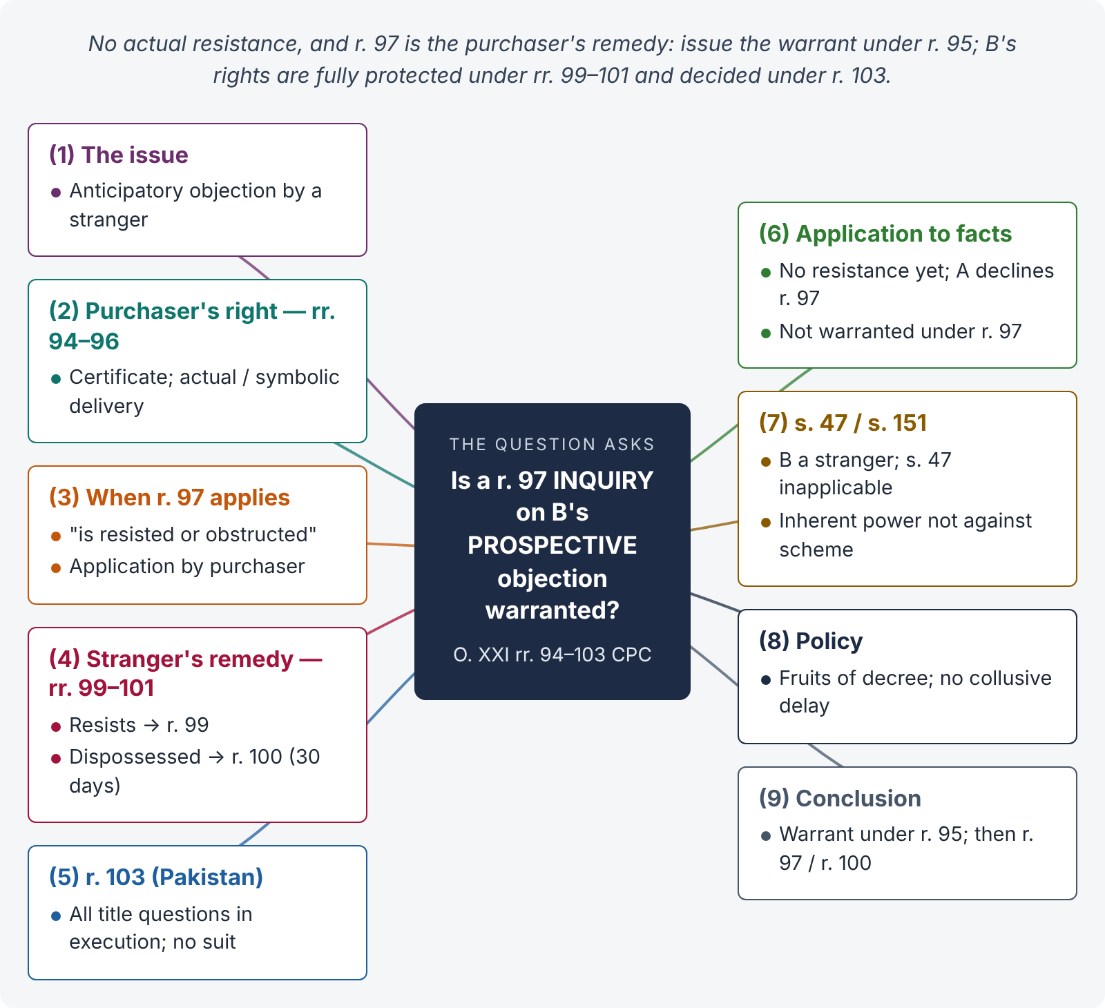
Figure 10 · The answer map: every branch is one numbered heading of the model answer below

Decoding the question
A pure execution-procedure problem. The examiner tests whether you know: (1) the purchaser's right to possession (rr. 94–96); (2) the trigger for r. 97 (actual resistance or obstruction, complained of by the decree-holder / purchaser); (3) the remedy of a stranger — after dispossession (r. 100), not before; (4) the Pakistani r. 103 (all questions of title and possession decided in execution, no separate suit); and (5) whether the court can nevertheless entertain B's objection under s. 47 / s. 151. A balanced, reasoned conclusion earns the marks.

The model answer

1. Introduction — the issue
The question is whether an executing court may treat a pre-emptive application by a third party (B), filed before any attempt to deliver possession, as "resistance or obstruction" and start an inquiry under O. XXI r. 97, over the auction-purchaser's (A's) objection.

2. The purchaser's right to possession — rr. 94 to 96
When the sale becomes absolute, the court grants a sale certificate (r. 94); the property vests in the purchaser from the date of sale (s. 65). On the purchaser's application, the court orders delivery: actual possession where the property is in the occupancy of the judgment-debtor "or of some person on his behalf or of some person claiming under a title created by the judgment-debtor subsequently to the attachment" (r. 95), and symbolic possession where a tenant is in occupation (r. 96). A has followed the correct course under r. 95.

3. When does r. 97 come in?
"Where the holder of a decree for the possession of immoveable property or the purchaser of any such property sold in execution of a decree is resisted or obstructed by any person in obtaining possession of the property, he may make an application to the Court complaining of such resistance or obstruction" (r. 97(1)). Two points follow:
- The trigger is actual resistance or obstruction in obtaining possession — a past fact, not a fear.
- The applicant under r. 97 is the decree-holder or purchaser, not the obstructer. Rule 97 is the purchaser's remedy, and he may choose whether to use it.

4. The stranger's remedy — rr. 99 to 101
A person other than the judgment-debtor claiming in good faith to be in possession on his own account is protected in two ways: (i) if he resists and the purchaser complains, the court, on inquiry, dismisses the purchaser's application (r. 99); (ii) if he is dispossessed, he may himself apply (r. 100) within 30 days (Art. 165), and if he was in possession on his own account he is restored (r. 101). A transferee pendente lite from the judgment-debtor gets no protection (r. 102).

5. Title decided in execution — r. 103 (Pakistan)
"All questions arising as to title, right or interest in, or possession of immoveable property between an applicant under rule 97 and the opposite party, or between an applicant under rule 100 and the opposite party, shall be adjudicated upon and determined by the Court, and no separate suit shall lie for the determination of any such matter" (r. 103, substituted by the Law Reforms Ordinance 1972). The orders are deemed decrees (s. 2(2)) and appealable as such.

6. Applying the rules — was the procedure warranted?

i) Strictly under r. 97 — no
(1) There has been no resistance or obstruction yet; A has not even gone to the spot. B's application is an anticipatory objection. (2) Rule 97 contemplates an application by A, which A declines to make. (3) B is not yet dispossessed, so r. 100 is not available to him either. On the plain words of rr. 97 and 100, the court could not deem B's application to be "resistance" and start a r. 97 inquiry at A's expense.

ii) The correct course on the rules
The court should issue the warrant of possession under r. 95. If B then resists, A may apply under r. 97 and the court will inquire (rr. 98–99, 103). If B is dispossessed, he may apply under r. 100 and the court will inquire (rr. 101, 103). Either way, B's title and possession will be fully adjudicated under r. 103.

7. Can the court act under s. 47 or s. 151?

i) Section 47
B is a stranger to the decree, not a party or a representative of a party; s. 47 does not govern a dispute between the purchaser and an independent stranger.

ii) Section 151
The court has inherent power "to make such orders as may be necessary for the ends of justice or to prevent abuse of the process" (s. 151, exercised with recorded reasons in Islamabad). Some courts have entertained such objections to avoid a breach of the peace and needless dispossession of a bona fide occupant, since r. 103 anyway makes the executing court the only forum. But inherent power cannot be used contrary to the scheme of the Code (Manohar Lal Chopra v. Seth Hiralal, AIR 1962 SC 527). Where the Code gives B a specific remedy after dispossession (r. 100) and gives A the choice under r. 97, the court should not override that scheme merely because B anticipates resistance.

8. Policy considerations
The purpose of O. XXI is to give the decree-holder / purchaser the fruits of the decree quickly. Allowing third parties to stall delivery by filing anticipatory objections would encourage collusive obstruction (often by the judgment-debtor's relatives). At the same time, a genuine occupant is fully protected by rr. 99–101 and the inquiry under r. 103 — with no separate suit, so nothing is lost by following the sequence the Code prescribes.

9. Conclusion
The procedure adopted by the executing court is not warranted by O. XXI r. 97: there was no actual resistance or obstruction, and the r. 97 application belongs to the purchaser, who declined to make it. The court should have issued the warrant of possession under r. 95, leaving B to resist (whereupon A may invoke r. 97) or, if dispossessed, to apply under r. 100 — in either event, the question of B's title and possession would be decided by the executing court under r. 103, with no separate suit. At most, for recorded reasons of preventing a breach of the peace, the court might note B's objection and direct the bailiff to report the facts — but it should not stall delivery by starting a r. 97 inquiry on a "prospective" objection.

Why this answer scores
- It quotes the exact trigger in r. 97 ("is resisted or obstructed") and identifies who may apply — the key to the problem.
- It sets out the complete Pakistani scheme — rr. 95–103, including r. 103 and Arts. 165/167 — and the s. 47 / s. 151 angles.
- It gives a clear verdict and the correct procedure, plus a balanced note on inherent powers.

Answer 9 · Procedure for executing a money decree; the competent court (PU LLB 2008)
AT A GLANCE · PUNJAB UNIVERSITY LLB (CPC) 2008 · Q. 7 · STANDARD JUDICIAL-EXAM QUESTION · 20 MARKS
Describe the procedure of execution of a money decree. Which Court has competent jurisdiction?

The answer map
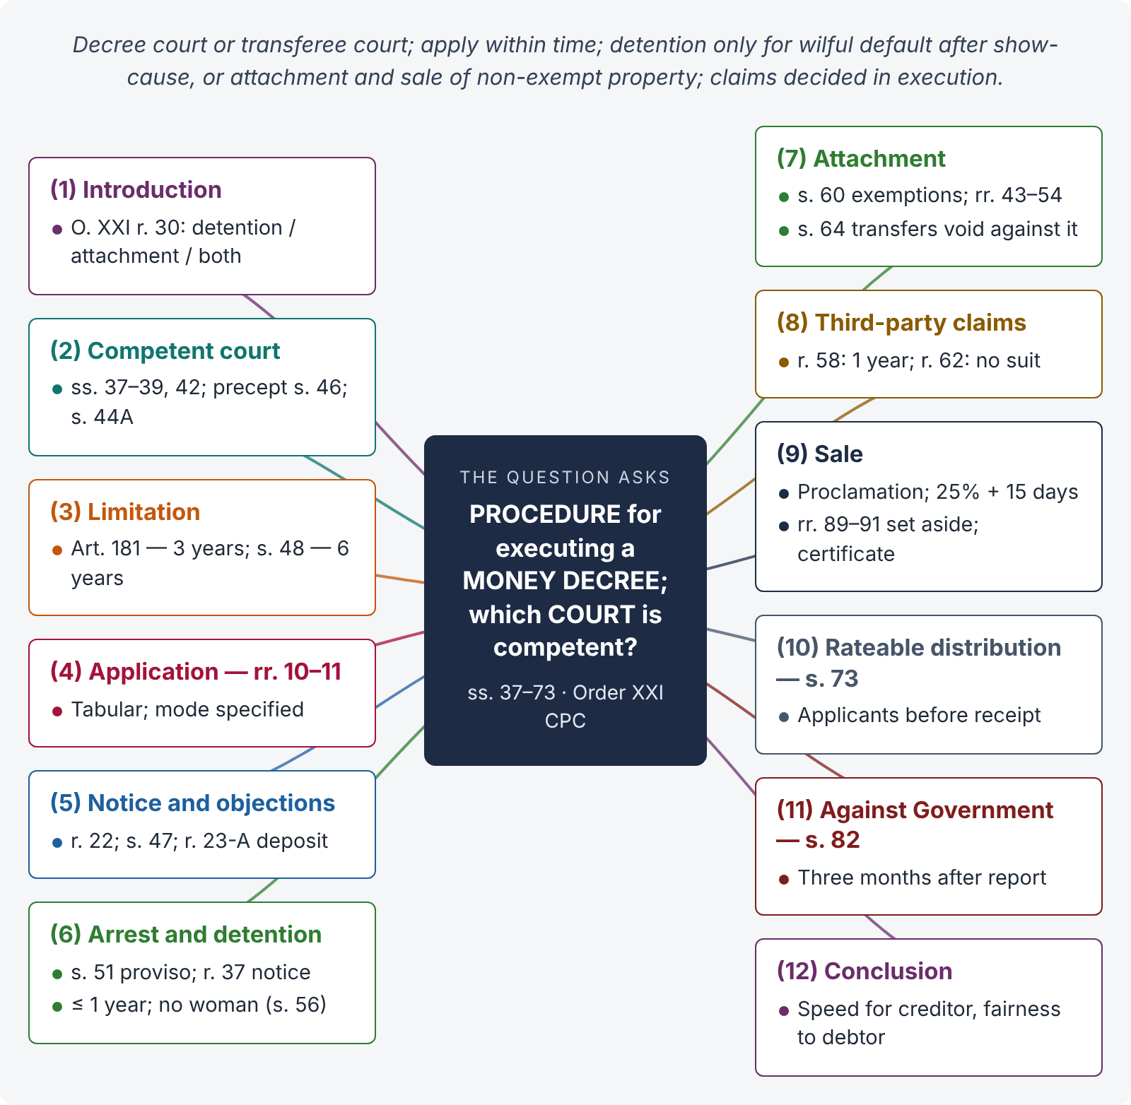
Figure 11 · The answer map: every branch is one numbered heading of the model answer below

Decoding the question
Two parts: which court (ss. 37–42, 46) and the procedure — from the application to satisfaction: limitation, the application, notice, objections (with r. 23-A), modes (arrest and detention; attachment and sale), exemptions, claims, sale, rateable distribution, and the Pakistani safeguards (s. 51 proviso, s. 56). A flowchart-style answer with sections and rules earns marks.

The model answer

1. Introduction — enforcing a money decree
A money decree orders the judgment-debtor to pay a sum of money. If he does not pay voluntarily, the decree-holder executes it through the court. "Every decree for the payment of money … may be executed by the detention in prison of the judgment-debtor, or by the attachment and sale of his property, or by both" (O. XXI r. 30).

2. Which court is competent?
- The court which passed the decree (s. 38) — including, where the decree was passed in appeal, the court of first instance, and where that court has ceased to exist or lost jurisdiction, the court that would now have jurisdiction (s. 37).
- The transferee court — the decree court may send the decree for execution where the judgment-debtor resides / works, or has property, elsewhere, or for other recorded reasons (s. 39); it then has the same powers as if it had passed the decree (s. 42).
- Precept — the decree court may direct another court to attach property pending transfer (two months) (s. 46).
- Foreign decrees of reciprocating territories may be executed under s. 44A by the District Court.

3. Limitation
The first application within three years (Art. 181 — Art. 182 was omitted in 1972); fresh applications within the six-year ceiling of s. 48, unless fraud or force by the judgment-debtor prevented execution.

4. The application — O. XXI rr. 10, 11
A written application in tabular form: suit number, parties, date of decree, appeals, payments or adjustments, amount due with interest and costs, the mode of execution (arrest; attachment of specified property), signed and verified (r. 11(2)). An oral application may be allowed for immediate arrest of a judgment-debtor present in court (r. 11(1)). For immovable property, a description and the judgment-debtor's share (r. 13).

5. Notice and objections — rr. 22, 23, 23-A; s. 47
- Notice to show cause if the application is made more than one year after the decree or against a legal representative (r. 22).
- Objections relating to execution, discharge or satisfaction are decided by the executing court under s. 47 — no separate suit.
- Pakistani rule — r. 23-A: "An objection by the judgment-debtor to the execution of a decree shall not be considered by the Court unless … he either deposits the decretal amount in Court or furnishes security for its payment."
- Uncertified payments out of court are not recognised (r. 2).

6. Mode 1 — arrest and detention

i) The safeguard
Detention "shall not be ordered unless, after giving the judgment-debtor an opportunity of showing cause", the court, for reasons recorded, is satisfied that he (a) is likely to abscond or has dishonestly transferred / concealed property; or (b) has the means to pay and refuses or neglects to pay; or (c) owes the sum in a fiduciary capacity (s. 51 proviso). Civil imprisonment is for wilful default, not for poverty (Jolly George Varghese v. Bank of Cochin, (1980) 2 SCC 360).

ii) Procedure
The court first issues a notice to show cause instead of a warrant, unless he is likely to abscond (O. XXI r. 37); inquiry; up to 15 days in custody / on security to pay (r. 40); then detention — simple imprisonment up to one year (s. 55(1)); release on payment or satisfaction (s. 58); detention does not discharge the debt but bars re-arrest under the same decree (s. 55(3)).

iii) Limits
No woman may be arrested or detained for a money decree (s. 56); no entry into a dwelling-house between sunset and sunrise; outer doors broken only if the judgment-debtor occupies and refuses access; privacy of women respected (s. 55(1) provisos).

7. Mode 2 — attachment of property
- What is attachable: all saleable property of the judgment-debtor (s. 60(1)) except necessaries, tools of trade, agriculturist's house and implements, books of account, mere right to sue, pensions, wages of labourers, salary beyond the first Rs. 100 and half the remainder, provident fund, future maintenance, expectancy, etc. (s. 60 proviso).
- How: movables by seizure (r. 43); debts and shares by prohibitory order — the garnishee may pay into court (r. 46); salary by order to the disbursing officer (r. 48); immovables by prohibitory order proclaimed at the spot and court-house (r. 54).
- Examination of the judgment-debtor on oath about his property (r. 41).
- Effect: any private transfer after attachment is void as against the attachment (s. 64).

8. Claims by third parties — rr. 58 to 62
A third party claiming the attached property must object within a reasonable time or one year of the first attachment (r. 58 proviso); he must prove title at the date of attachment (r. 59); the court releases or continues attachment (rr. 60–61) and finally decides title — no separate suit (r. 62; r. 63 omitted).

9. Sale and realisation — rr. 64 to 94
Proclamation after notice (r. 66); no sale within 30 days (immovable) / 15 days (movable) (r. 68); public auction; decree-holder bids only with leave (r. 72); purchaser deposits 25% at once and the balance within 15 days (rr. 84–85); sale may be set aside on deposit (r. 89), for material irregularity or fraud with substantial injury (r. 90 — deposit up to 20%), or no saleable interest (r. 91) — within 30 days (Art. 166); confirmation and certificate (rr. 92, 94).

10. Distribution of proceeds — s. 73
Where several money decree-holders have applied to the same court before receipt of the assets, the proceeds are rateably distributed among them after costs (s. 73).

11. Execution against Government
A decree against Government or a public officer (for an official act) specifies a time for satisfaction; execution cannot issue until three months after the court's report to Government (s. 82).

12. Conclusion
A money decree is executed by the court that passed it or a transferee court (ss. 37–42), on a timely application (Art. 181; s. 48), through detention of the judgment-debtor — only for wilful default after show-cause — or attachment and sale of non-exempt property, with third-party claims and objections decided finally within execution and the proceeds distributed rateably. The Pakistani additions — deposit before objection (r. 23-A), no separate suit (rr. 62, 103) and no arrest of women (s. 56) — balance speed for the creditor with fairness to the debtor.

Why this answer scores
- It answers both parts — forum and procedure — in the order a court actually proceeds.
- Every step carries its section / rule and the key numbers (3 / 6 years; 1 year; Rs. 100 + half; 25% / 15 days; 30 days).
- It shows Pakistani features (r. 23-A, s. 56, r. 62 / r. 63 omitted, Art. 182 omitted).
- Jolly George Varghese anchors the human-rights limit on civil imprisonment.

Answer 10 · Suit against Government without notice — s. 80 and Order XXVII (PU LLB 2007)
AT A GLANCE · PUNJAB UNIVERSITY LLB (CPC) 2007 · Q. 4 · STANDARD JUDICIAL-EXAM QUESTION · 20 MARKS
Can a suit be filed against Government without serving a notice? What are its details?

The answer map
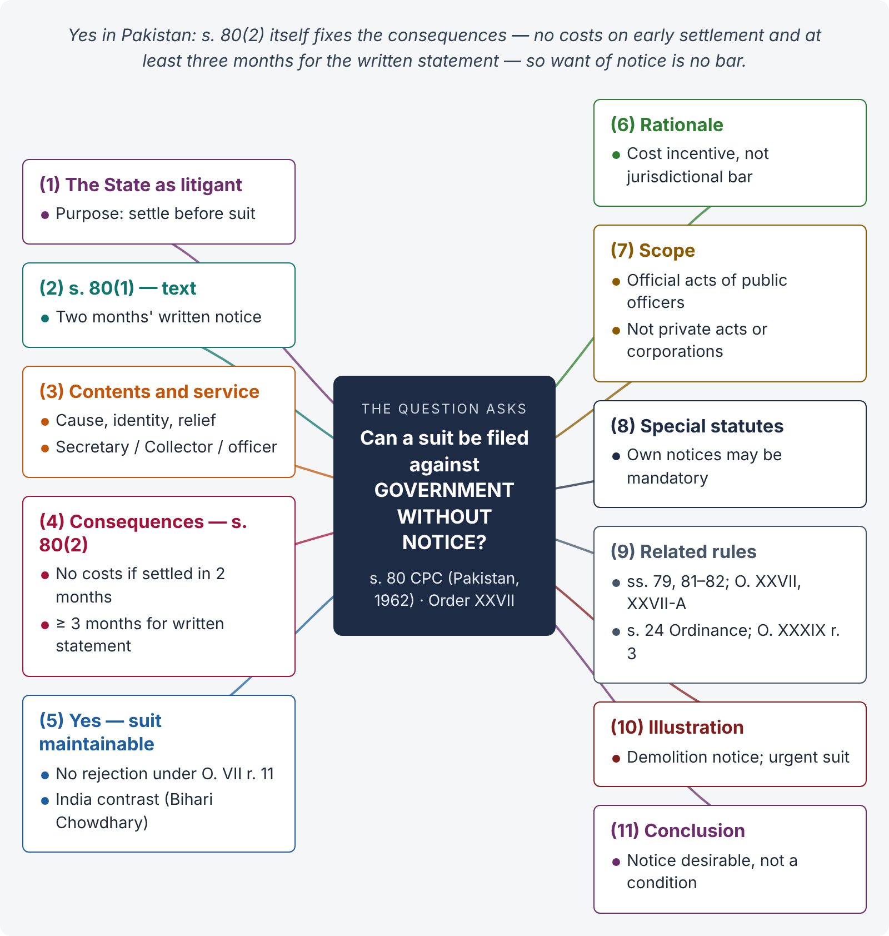
Figure 12 · The answer map: every branch is one numbered heading of the model answer below

Decoding the question
The short answer in Pakistan is "Yes" — s. 80 (as substituted in 1962) does not bar a suit filed without notice; it only affects costs and the time for the written statement. Most textbooks (Indian) say the opposite. The "details" are: the contents of the notice, to whom it is given, the two-month period, the consequences of non-compliance under s. 80(2), the purpose, and related rules — s. 79 (naming), s. 81–82, O. XXVII, O. XXVII-A, s. 24 of the Civil Courts Ordinance (forum), and special statutes with their own mandatory notices.

The model answer

1. Introduction — the State as litigant
The Government is the largest litigant in Pakistan. The CPC gives it some procedural privileges — chiefly a prior notice before it is sued — so that it can examine claims and settle genuine ones without litigation. The question is whether the notice is a condition precedent to a suit.

2. The text of s. 80(1)
"A suit may be instituted against the Government or against a public officer, in respect of any act purporting to be done by such public officer in his official capacity, after the expiration of two months next after notice in writing has been delivered to or left at the office of — (a) in the case of a suit against the Federal Government, a Secretary to that Government; (b) in the case of a suit against a Provincial Government, a Secretary to that Government or the Collector of the District …; and in the case of a public officer, delivered to him or left at his office, stating the cause of action, the name, description and place of residence of the plaintiff and the relief which he claims; and the plaint shall contain a statement that such notice has been so delivered or left."

3. Contents and service of the notice
The notice must (1) be in writing; (2) state the cause of action; (3) give the plaintiff's name, description and residence; (4) state the relief claimed; (5) be delivered to or left at the office of the Secretary (Federal / Provincial), the Collector (provincial), or the public officer concerned; and (6) the suit is filed after two months, with a statement in the plaint that notice was given.

4. Consequences of not giving notice — s. 80(2) (Pakistan)
"Where any such suit is instituted without delivering or leaving such notice … or before the expiration of the said period of two months or where the plaint does not contain a statement that such notice has been so delivered or left, the plaintiff shall not be entitled to any costs if settlement as regards the subject-matter of the suit is reached or the Government or the public officer concedes the plaintiff's claim, within the period of two months from the date of the institution of the suit: Provided that in a suit instituted without such notice, the Court shall allow not less than three months to the Government to submit its written statement."

5. So — can the suit be filed without notice? Yes
- Section 80 itself provides what happens if notice is not given: loss of costs in case of early settlement, and extended time for the written statement.
- It does not say that the suit shall be dismissed or the plaint rejected; therefore want of notice is not a ground for rejection under O. VII r. 11(d) ("barred by any law").
- This is the Pakistani position since the substitution of s. 80 by Ordinance XLIV of 1962. In India, s. 80 remains mandatory and a suit without notice is not maintainable (Bihari Chowdhary v. State of Bihar, (1984) 2 SCC 627) — a contrast worth stating.

6. Rationale
The notice gives Government a chance to reconsider its position and settle just claims, avoiding public expense. Pakistan keeps this purpose through a cost incentive rather than a jurisdictional bar, so that a citizen with a genuine grievance — especially one needing urgent relief such as an injunction against demolition — is not shut out of court by a technicality.

7. Which suits — scope of s. 80
Suits against Government (any act), and against a public officer for an act "purporting to be done … in his official capacity" (whether within or in excess of authority). Not covered: suits against a public officer for private acts, or suits against statutory corporations that are not "Government" (their own statutes may require notice).

8. Special statutes with their own notices
Some special laws require a notice before suit as a condition, or provide a special limitation for suits against their authorities. Such statutory requirements must be examined under those statutes; s. 80's Pakistani rule does not automatically dilute them. In an exam answer, flag the distinction.

9. Related privileges and rules
- s. 79: the defendant is named "Pakistan" or "the Province".
- s. 81: no arrest or attachment (except in execution); exemption from personal appearance where public service would suffer.
- s. 82: decree to specify time for satisfaction; execution only three months after report to Government.
- O. XXVII: pleadings signed / verified by appointed officers (r. 1); Government pleader receives process (r. 4); reasonable time to answer (r. 5); time for a public officer to make a reference (r. 7); no security from Government for stay (r. 8A).
- O. XXVII-A: notice to the Attorney General / Advocate General in cases involving a substantial question of constitutional interpretation.
- s. 24, Civil Courts Ordinance 1962: such suits only before a Civil Judge with unlimited pecuniary jurisdiction, at district headquarters.
- O. XXXIX r. 3: injunction against Government only after notice (2–7 days), unless the case involves ejectment or demolition.
- s. 35C: Government is not liable for actual / adjournment / special costs under ss. 35–35B.

10. Illustration
On 1 March the Capital Administration issues a notice to demolish a boundary wall of Naveed's house in E-11 within 48 hours. Naveed files a suit on 2 March for declaration and injunction without a s. 80 notice. The suit is maintainable; the court may issue an injunction (notice may be dispensed with under O. XXXIX r. 3 because the case involves demolition) and must allow the Government at least three months for its written statement. If the Government concedes the claim within two months, Naveed will get no costs.

11. Conclusion
Yes — in Pakistan, a suit may be filed against Government or a public officer without a s. 80 notice. The notice remains desirable: its absence costs the plaintiff his costs if the claim is settled within two months, and gives Government at least three months for its written statement — but it is not a condition precedent and does not make the suit incompetent. The "details" of suing Government — naming (s. 79), privileges (ss. 81–82, O. XXVII), forum (s. 24 Ordinance) and special statutory notices — complete the picture.

Why this answer scores
- It gives the correct Pakistani answer at once and proves it from the text of s. 80(2) — while noting the contrary Indian rule.
- It covers all the details: contents, addressees, two months, consequences, scope.
- It connects s. 80 with s. 79, ss. 81–82, O. XXVII, O. XXVII-A, O. XXXIX r. 3 and s. 24 of the Ordinance — integrated knowledge.
- A short illustration shows the rule working in an urgent case.

